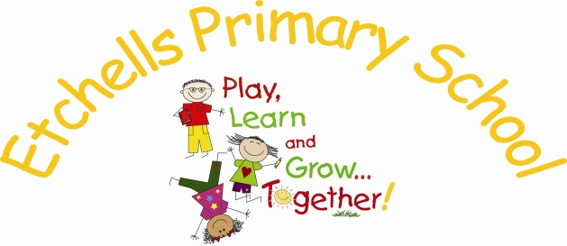

PSHE Policy

Introduction:
At Etchells Primary School, Personal, Social and Health Education (PSHE) is a central tenet of the Curriculum we offer our learners. It is also imbued in every aspect of our school life. PSHE is of central importance to us because it promotes pupils’ personal, social and emotional development, as well as their health and wellbeing. It equips children with the knowledge and skills they need to lead healthy, happy and independent lives. It aims to help them to understand how they are developing personally and socially, and tackles many of the moral, social and cultural issues that are part of growing up. It gives children an understanding of the rights and responsibilities that are part of being a good citizen and helps them to understand the British values which will enable them to be upstanding, active young citizens.

Aims:

At Etchells Primary School, we believe that PSHE - in conjunction with citizenship education and an understanding of Modern British values - plays a significant part in children’s ability to learn. We understand that only children who feel happy and safe can learn effectively. We value the importance of PSHE in preparing children for the opportunities, responsibilities and experiences of adult life. In addition we believe that a child needs to learn about the many emotional aspects of life and how to manage their own emotions.

At Etchells Primary School, we aim to help the children to:
- develop confidence and responsibilities and make the most of children’s capabilities and talents.
- prepare to play an active role as citizens in modern Britain, understanding the values our society holds.
- develop a healthy, safe lifestyle with the ability to make responsible choices.
- develop good relationships and to respect and celebrate the differences between people.
- make a positive contribution to the life of the school
Organisation:

We follow Stockport Local Authority’s scheme for teaching PSHE. This means that children receive a broad and balanced range of PSHE experiences. Each half-term, they will learn an age-appropriate aspect of Social & Emotional Aspects of Learning (SEAL), Relationships & Sex Education (RSE), Drugs & Tobacco Education (DATE) and E-Safety. Discrete PSHE lessons are timetabled for each class once per week. Work set for children may be written, creative or oral.

Additionally, class teachers tailor PSHE to the needs of the class. Circle Times are held to discuss any worries or issues the children may be facing, or simply to share views and opinions in a safe and respectful forum.

Our school environment reflects our commitment to teaching the children about the importance Modern British Values.

Social, Moral, Spiritual & Cultural development opportunities are a continual thread running through the Curriculum we offer our children.

Relation to School Aims:

Our school ethos supports the delivery of PSHE in the following ways:

- PSHE, citizenship and Modern British Values education, as well as SMSC development opportunities help children to be self-aware and responsible – for their actions and for their learning.
- Our programme of PSHE, citizenship, Modern British Values and SMSC development encourage our learners to value equality and meritocracy; therefore everybody is supported in realising their true potential, regardless of the factors which make us different.
- Social, moral, spiritual and cultural development opportunities are at the heart of our vision, our environment and our work – from team-building residential trips to democracy in action in our school through electing our Head Girl and Boy, from assemblies given by visitors of a variety of faiths to recognition of important religious festivals, such as Diwali, Eid and Rosh Hashana.
- Our happy, caring environment provides children with a safe place in which they can try new things, challenge themselves and grow.
- Our commitment to creating links with our wider community underlines our commitment to PSHE, citizenship, Modern British Values and SMSC development: we invite our community in to help us celebrate at Christmas and to support worthy causes, such as Macmillan, and we reach out to our community, caring for our environment and supporting local groups such as the Wellspring Centre.

PSHE, Citizenship, Modern British Values and SMSC development opportunities will enable children to practise specific skills in structured contexts and in their daily life including:
1. Encouraging everybody to take responsibility for their actions through the agreement of class rules.
2. Involving children in assessing their own learning. What is going well? What do I need to do to take the next step in my learning?
3. Encouraging children to recognise and respect differences between people.
4. The democratic election of a Head Boy and Girl, to be a leader for their peers and ambassadors for our school.
5. Encouraging children to take responsibility for their behaviour.

There are wider opportunities for personal and social development at school. These include:-
1. The development of each child’s ability to work as part of a team, become active within the school community and recognise the qualities of good citizenship.
2. Planning class visits and trips which widen children’s experiences beyond their immediate local environment.
4. Coming together as a school for assemblies to celebrate academic and personal achievements.
5. Planning events which encourage the school to work together, for example: Christmas productions, charity events, sports day and the summer fair.

Responsibilities:
The PSHE co-ordinator is responsible for leading PSHE, citizenship, Modern British Values and SMSC development. This entails:
- Monitoring the teaching and learning of PSHE.
- Overseeing and implementing the policy.
- Writing an annual action plan for The School Improvement Plan and evaluating progress throughout the year.
- Attending training and keeping teaching staff up to date with developments.
- Ensuring staff are implementing the Prevent Duty Training received in January 2016

All class teachers are responsible for planning - using the agreed scheme - and delivering weekly lessons, and seeking opportunities throughout the Curriculum to enable children to develop these skills and understandings.

