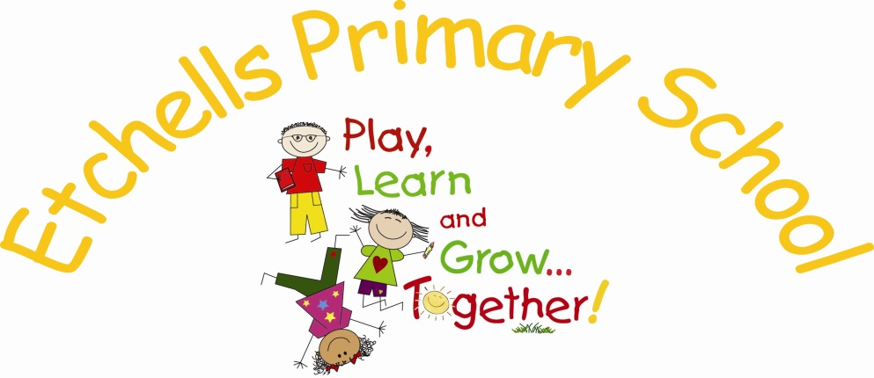

Teaching and Learning
POLICY

February 2016


 |  |  | 
February 2016 | 1.0 | Rewritten for the new National Curriculum | J.Mallinson
 |  | Presented to Governors Spring 2016

KEY PRINCIPLES
AT ETCHELLS WE BELIEVE CHILDREN LEARN BEST WHEN:
- learning activities are well planned, ensuring progress in the short, medium and long term
- teaching and learning activities enthuse, engage and motivate children to learn, and foster their curiosity and enthusiasm for learning
- assessment informs teaching so that there is provision for support, repetition and extension of learning for each child, at each level of attainment
- the learning environment is ordered, the atmosphere is purposeful and children feel safe

1 CHILDREN LEARN BEST WHEN LEARNING ACTIVITIES ARE WELL PLANNED, ENSURING PROGRESS IN THE SHORT, MEDIUM AND LONG TERM.
THERE WILL BE EVIDENCE IN THE LEARNING ENVIRONMENT OF:
- effective focussed learning activities with clear learning challenges and success criteria
- a clear understanding by the children of the method and purpose of activities in which they engage
- progress in the children’s learning (in their books, on the walls, in conversation, in their learning behaviour)
TEACHERS WILL ENSURE THAT:
  - work is planned, on a long, medium and short term basis. Weekly plans are prepared for English and Maths
  - termly and weekly plans adhere to the progression of skills in the Curriculum Map
  - planning is holistic, recognising connections between areas of learning and taking into account the role teaching has in promoting the children’s spiritual, moral, social and cultural development
IMPLICATIONS FOR THE WHOLE SCHOOL WILL BE:
- there is a Skills Continuum in place that ensures continuity and progression on the website
- there are year group Curriculum Maps in place that is broad and balanced
- where there are agreed schemes of work in place, these are known to all and are detailed in subject specific curriculum policies and the foundation curriculum policy
- subject specific curriculum action plans are in place
- a monitoring cycle is in place to support the progress of individuals and groups of learners: Pupil Voice, lesson drop-ins, planning scrutiny, book-looks

2. CHILDREN LEARN BEST WHEN TEACHING AND LEARNING ACTIVITIES ENTHUSE, ENGAGE AND MOTIVATE THEM TO LEARN, AND WHEN THEY FOSTER THEIR CURIOSITY AND ENTHUSIASM FOR LEARNING.
THERE WILL BE EVIDENCE IN THE LEARNING ENVIRONMENT OF:
- creative teaching and creative learning
- teaching that avails the construction of skill and knowledge structures, making learning accessible and motivating for children
- learning-activities that enthuse pupils so that they persevere when faced with difficult problems and are keen to succeed and to learn more
- children learning independently
- children collaborating on projects
- children enjoying their learning
TEACHERS WILL MAKE SURE THAT:
- well judged and effective teaching strategies successfully engage pupils in their learning
- they use their expertise, including their subject knowledge, to develop pupils’ knowledge, skills and understanding in a structured way, across the range of subjects and areas of learning. Share their strengths by team teaching, lesson study and collaborative planning
- well framed questions, knowledgeable answers and the use of discussion, promotes deep learning
- appropriate open-ended home-learning is set to nurture children’s enthusiasm and curiosity, and develop their understanding in areas under study
IMPLICATIONS FOR THE WHOLE SCHOOL WILL BE:
  - learning and learning outcomes, both within school and at home, are celebrated regularly in public forums such as Star of the Week Assembly, the weekly newsletter, Twitter and class web pages
  - whole school themes provide points of shared discussion and motivate learners across the school

3. CHILDREN LEARN BEST WHEN ASSESSMENT INFORMS TEACHING SO THAT THERE IS PROVISION FOR SUPPORT, REPETITION AND EXTENSION OF LEARNING FOR EACH CHILD, AT EACH LEVEL OF ATTAINMENT.
THERE WILL BE EVIDENCE IN THE LEARNING ENVIRONMENT OF:
- children using frequent, detailed and accurate feedback from teachers, both oral and written, to improve their learning – eg redrafting writing in collaboration with the teacher, use of purple pen to respond to feedback, engaging in self and peer assessment
- children who are motivated to learn through differentiated learning-activities that build on their prior attainment and issue challenge that is pitched at a level that is achievable when they work hard and try their very best
- children with specific learning needs receiving support at the time and level it is required to optimise their learning
- pupils supporting one another where appropriate
- independent learning, where children use assessment information to direct their own learning activity
TEACHERS WILL MAKE SURE THAT:
- the pace and depth of learning is maximised as a result of their monitoring of learning during lessons and any consequent actions in response to pupils’ feedback
- marking is frequent and regular (see marking policy “The Etchells Way”), providing pupils with very clear guidance on how learning outcomes can be improved
- they have high expectations for all children, and plan, resource and direct differentiated learning activities that give support and issue challenge for all
- they keep agreed ARE assessment records and submit data termly to enable Pupil Data Tracking (reading, writing and mathematics)
- engage in pupil progress reviews in January and April with Phase
- Leader and Head teacher
IMPLICATIONS FOR THE WHOLE SCHOOL WILL BE:
  - there is an Assessment policy in place that ensures consistency of practice
  - there is an efficient system of Pupil Data Tracking in place; data is scrutinised rigorously in Pupil Progress Meetings involving year group partner teachers and members of the Senior Leadership Team; this data is utilised in the deployment of resources
  - there is an Inclusion Team to support staff, children and parents in their teaching and learning, providing advice and intervention where necessary

4. CHILDREN LEARN BEST WHEN THE LEARNING ENVIRONMENT IS ORDERED, THE ATMOSPHERE IS PURPOSEFUL AND THEY FEEL SAFE.
THERE WILL BE EVIDENCE IN THE LEARNING ENVIRONMENT OF:
- an atmosphere of mutual respect between adults and children
- children who feel secure to speak and act freely, enjoying freedom from bullying and harassment that may include prejudice-based bullying related to special educational need, sexual orientation, sex, race, religion and belief, gender reassignment or disability
- children’s high self esteem, with all children feeling valued and secure
- children taking risks in their learning, and learning from their mistakes
- children’s learning outcomes displayed around the classroom and the school for others to appreciate and admire
- organisation of classroom routines and resources to optimise learning
TEACHERS WILL MAKE SURE THAT:
  - they teach children how to behave well
  - they employ positive strategies for managing children’s behaviour that help pupils understand the school’s expectations and that these strategies are underpinned by the clear range of rewards and sanctions set out in the schools behaviour policy, and these are applied fairly and consistently
  - good behaviour is modelled by them at all times in their interaction with children and other adults with conflict dealt with in a calm and fair manner – they will not shout or lose their temper
  - children will be encouraged in their learning and their efforts will be praised both in the classroom and in assemblies
  - any criticism will be constructive and children’s self esteem will always be maintained

IMPLICATIONS FOR THE WHOLE SCHOOL:
- a clear behaviour policy is in place and all adults working in the school have a complete understanding of its content so that it is applied fairly and consistently across the whole school
- high expectations of behaviour, including children’s attendance and punctuality at school, are communicated to, and shared by, all children, parents and staff
- rigorous safe guarding procedures are in place and are adhered to

