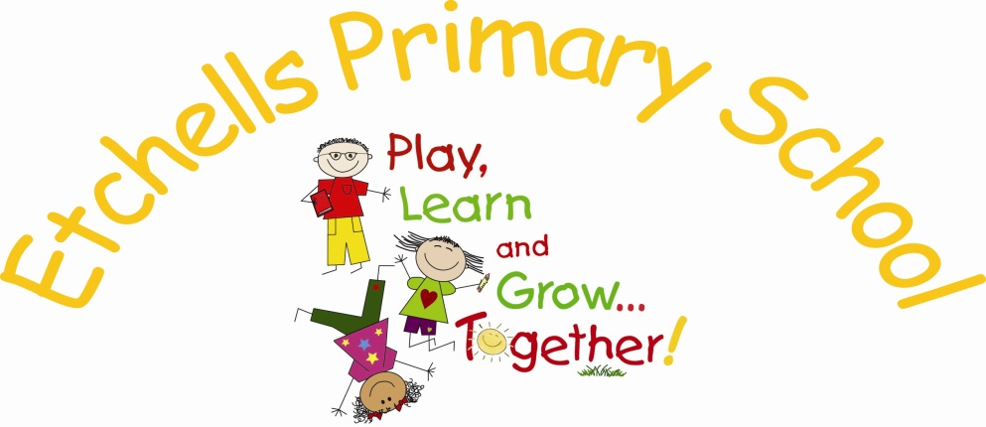

CURRICULUM
POLICY
(Foundation subjects)

July 2016


 |  |  | 
Spring 2016 | 1.0 | Policy re-written in light of New national Curriculum. Agreed by Governors. | J.Mallinson

Introduction

The curriculum encompasses all the planned activities that we organise in order to promote learning, personal growth and development. It includes not only the formal requirements of the National Curriculum, but includes the ‘hidden curriculum’, or what the children learn from the way they are treated and expected to behave. We are committed to developing the whole child. We aim to teach children how to grow into positive, responsible people, who can work and co-operate with others while developing knowledge and skills, so that they achieve their true potential.
Our aim is to deliver child initiated, text focused and subject topics, with the overall aim of enabling:
Real opportunities for learning
Engaging and enjoyable learning
High academic and personal achievement
Manageable, creative and exciting teaching opportunities

Values
We value the way in which all children are unique, and our curriculum promotes respect for the views of each individual child.
We respect each child in our school for who they are, and we treat them with fairness and honesty.
We aim to enable each person to be successful, and we provide equal opportunities for all the children in our school.
Parents are informed about the curriculum and up to date events through our website, topic letters, homework activity sheets, Twitter and weekly newsletters.

Aims and Objectives
The aims of our school curriculum are:
To enable all children to understand that they can all be successful learners.
To promote a positive attitude towards learning, involving children in initiating ideas during the topic planning stage so that children enjoy coming to school
To teach children the basic skills of English and Maths;
Through a cross curricular thematic approach provide children opportunities to be creative through art, dance, music, drama and design technology;
To enable children to be healthy individuals who enjoy sport and appreciate the importance of a healthy life style.
To teach children about their developing world, including how their environment and society have changed over time;
To help children understand Britain’s cultural heritage and Modern British Values;
To enable children to be positive citizens in society and to feel that they can make a difference;
To enable children to understand and respect other cultures;
To fulfil all the requirements of the National Curriculum syllabus for Religious Education;
To teach children to have an awareness of their own spiritual development, and to understand right from wrong;
To help children understand the importance of truth and fairness, so that they grow up committed to equal opportunities for all;
To enable children to have respect for themselves and high self-esteem, and to be able to live and work co-operatively with others;
To incorporate Social, Moral, Spiritual and Cultural teaching throughout the curriculum and maximise opportunities to develop these areas further.

Organisation and Planning
Long term planning is carried out in Year groups and in collaboration within each Key phase: EYFS. Key Stage 1, Lower Key Stage 2 and Upper Key Stage 2.
In most subject areas, subject leaders have drawn up a 2 year plan to ensure the New National Curriculum (2014) is covered appropriately. In subjects such as Music, French and Computing schemes of work are followed and support planning. The table overleaf indicates the sources of planning underpinning each subject:

Subject | Planning
Geography | Chris Trevor progression of skills
History | Chris Trevor progression of skills
RE | Chester Scheme of work
Science | National Curriculum Programme of Study
ICT/Computing | Rising Stars switched on to computing/Coding
Art | Chris Quigley Essentials
Music | Music Express
Languages (French) | iLanguages
Design and Technology | Chris Quigley Essentials
PSHE | Stockport focussed resources
PE | Val Sabin

Teachers decide on the themes of the topics. These may be child-initiated, based on a quality text or subject specific, for example, Design and Technology.
Medium term plans indicate the areas of the National Curriculum to be covered and include an outline of the learning activities and outcomes. We expect these plans to change in response to the children’s learning and prior knowledge and for hard copies to be annotated.
Our short-term plans are those that our teachers write on a weekly basis, these are for writing, reading and maths. They are shared with Teaching Assistants in designated meeting times, to ensure clarity of their role, lesson objective and to give feedback from groups they have worked with.
The two year coverage map and termly planning is closely monitored by the subject leader; advice is given to ensure complete coverage of content and skill progression. This is built in as part of our termly cycle of monitoring.
Work for all Foundation subjects is recorded in the pupil’s Foundation Book; this has a blue cover and the Etchells logo on the front. This is the only workbook in addition to the Maths and English books.

The Role of the Subject Leader
The role of the subject leader is to:
• Provide a strategic lead and direction for the subject;
• Annually, create an action plan for the subject, linking in to the School Development Plan and focussing on the improvement of teaching and learning.
• Support and offer advice to colleagues on issues related to the subject;
• Monitor pupil progress in that subject area;
• Provide efficient resource management for the subject.
It is the role of each subject leader to keep up to date with developments in their subject, at both national and local level. They review the way the subject is taught in the school and plan for improvement.
(Also refer to Subject Leaders Handbook)

Children with Special Needs
Etchells is in the privileged position to be a resourced school and operates a fully inclusive approach for children different special needs. There is a dedicated team of RSIAs led by the Resource Base Manager/SENCO, who work to integrate children in the classrooms. The curriculum in our school is designed to provide access and opportunity for all children who attend the school. If we think it necessary to adapt the curriculum to meet the needs of individual children, then we do so. For the majority of the Resource Base children we use PIVATs to plan, set targets and assess learning and progress.
We comply with the requirements set out in the SEN Code of Practice in providing for children with special needs. (Also refer to SEN Policy)

EYFS
In Nursery and Reception we provide a balance between child-initiated and adult directed activities, with emphasis placed on developing a broad range of skills, underpinned by The Early Years Foundation Stage Curriculum. There are seven areas of learning within the Foundation Stage Curriculum: Communication & Language, Personal, Social & Emotional Development, Physical Development, Literacy, Mathematics, Understanding the World and Expressive Arts & Design. Children are provided with opportunities to play and learn both indoors and outside.
We take pride in planning activities in response to the children's interests and ensure that activities are challenging, fun and purposeful. We develop their characteristics of effective learning through opportunities to play and explore, be active in their learning, make decisions, share ideas, be creative and think critically. We celebrate all children’s efforts and achievements. Children’s progress is collated in their ‘Learning Journeys’ and through ‘2build a profile’ assessment tool on the teacher’s iPads.
Through early, accurate Baseline Assessment we record each child’s starting points then identify and plan for their next steps for learning. Their progress towards the Age Related Expectations (AREs) is closely tracked throughout the year and regularly shared with parents to support the children’s development both in school and at home. We recognise the crucial role of parental involvement in a child's education and provide regular communication regarding children's progress.
Our aim is for our children to be happy, settled and secure at school; for them to develop a love of learning and have the confidence to be independent and resilient learners. We consider the changing ‘school readiness’ needs of the children as they move on to their next phase of education.
Monitoring and Review
Our governing body’s Curriculum Committee is responsible for monitoring the way the school curriculum is implemented.
The Deputy Headteacher is responsible for the day to day organisation of the foundation curriculum.
Subject leaders monitor the way their subject is taught throughout the school.
They examine long-term and medium-term planning, Drop in sessions and Foundation book monitoring ensure that appropriate teaching strategies are used. Subject leaders have responsibility for monitoring standards and ensuring that teachers have the skills and resources they need.

REVIEW
The Governing Body will review this policy statement annually and update, modify or amend it as it considers necessary to ensure the policy meets the needs of Etchells Primary School.
Signed …………………………………………Date ………………

(Chair of Governors)

Signed …………………………………………Date ……………..
(Headteacher)

