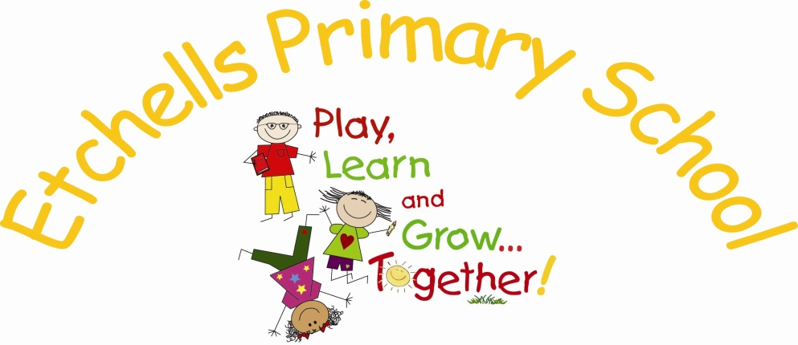

Art & Design
POLICY

March 2018

VERSION HISTORY

Date | Document Version | Document Revision History | Document Author/Reviser
March 2018 | 1.0 | Policy prepared ready for 24th April 2018 | S. Richards

Art and Design is a foundation subject in the National Curriculum and such is a statutory part of every child’s education.
Art should be interpreted to mean ‘Art, Craft and Design’.
This Policy outlines the purpose, nature and management of Art and Design in Etchells Primary School.
The implementation of this Policy is the responsibility of the staff.

THE NATURE OF ART AND DESIGN
Art and Design is the expression of ideas, thoughts and feelings through sensory experience in a wide variety of 2 and 3D media. Art is also a subject concerned with the development of visual perception and literacy.
It enables the understanding and appreciation of art from a variety of styles, cultures and periods through time and in doing so has the power to enrich our personal and public lives.

AIMS
The main aims are:

- to provide a rich and balanced framework in which every child’s abilities can be realised and developed

- to promote enjoyment and appreciation of art made by themselves, their peers and adults

- to develop a range of skills and techniques – thinking, making, communicating – in order that pupils become confident enough to communicate their ideas and visual statements

- to adopt a cross-curricular approach in which children can express their creativity

Through achieving the following objectives our aims will be realised.
OBJECTIVES
To provide all children with the opportunity to:
- participate in practical art activities, using a variety of materials, tools and techniques including ICT with increasing confidence and progression
- experience, enjoy and appraise a range of art works from a variety of different cultures, past and present
- communicate their artistic intentions using various methods, including orally, in writing, drawing and 3D modelling
- appreciate the need for care of tools and the safe working practices to be employed when working
- work in different groupings – individually, in pairs, small groups and large groups – to produce art work
- use appropriate drawing, painting and modelling skills to develop, express and communicate their ideas
- to respond to the work of different artists, crafts people and designers, applying knowledge in their own work
- experience their own art work being valued through display and sharing work with others
- develop specialist vocabulary, in order that children can engage in discussion about line, colour, shape, texture, form and tone when referring to art work of others as well as their own
- use a sketchbook to record ideas, experiment and explore (in KS2)
- find out about art, craft and design by extracting information from sources such as reference books, CD-ROMs, e-mails, the Internet and during visits to or out of school
- explore a range of cross-curricular starting points for practical work including drama and music

EYFS
For Early Years Foundation Stage, Art and Design comes under the umbrella of ‘Expressive arts and design’. For details, refer to the EYFS STATUTORY FRAMEWORK 2017.
Expressive arts and design involves enabling children to explore and play with a wide range of media and materials, as well as providing opportunities and encouragement for sharing their thoughts, ideas and feelings through a variety of activities in art, music, movement, dance, role-play, and design and technology.

RISK ASSESSMENT
When members of staff go out on art-based trips, an appropriate risk assessment will be produced.
For general art activities within school, members of staff are aware of low risk regarding art equipment such as scissors, glue, paintbrushes, pointed equipment. Specialist art activities involving a high risk, eg solvent-based products will be administered by members of staff or outside artists when children are not present. The glue gun will be used by an adult only – extreme caution must be taken. If possible, the procedure can be recorded to show the children of the process(es).
ART PROGRESSION IN PHASE GROUPS
This document aims to track expectations for Art within Etchells Primary School
What the National Curriculum says:
Key Stage 1 | Key Stage 2
Pupils should be taught:  - to use a range of materials creatively to design and make products  - to use drawing, painting and sculpture to develop and share their ideas, experiences and imagination  - to develop a wide range of art and design techniques in using colour, pattern, texture, line, shape, form and space  - about the work of a range of artists, craft makers and designers, describing the differences and similarities between different practices and disciplines, and making links to their own work. | Pupils should be taught to develop their techniques, including their control and their use of materials, with creativity, experimentation and an increasing awareness of different kinds of art, craft and design.  Pupils should be taught:  - to create sketch books to record their observations and use them to review and revisit ideas  - to improve their mastery of art and design techniques, including drawing, painting and sculpture with a range of materials [for example, pencil, charcoal, paint, clay]  - about great artists, architects and designers in history.

ART AND DESIGN SKILLS
Our skills and milestones document is taken from the Chris Quigley Essentials and then made bespoke to our school.

ASSESSING PROGRESS
The work children do will serve as a record. Sample photographs of art displays and children’s individual artwork will be kept in Foundation books/sketchbooks to show range and progression across the key stages.
The end of phase Chris Quigley milestones provides broad descriptions and should help teachers decide where a child’s progress differs from that of the rest of the class. Progress will be reported back to parents in the annual report. An annual record will be kept on the new phase group record sheet from Year 1 upwards, detailing children below expectation and those exceeding.

Milestone 1 By End of Year 2
Develop ideas | Below Expectation | To take inspiration from the greats (classic and modern) | Below Expectation
•Respond to ideas and starting points.  • Explore ideas and collect visual information.  • Explore different methods and materials as ideas develop. |  | • Describe the work of notable artists, artisans and designers.  • Use some of the ideas of artists studied to create pieces.
Painting | Below Expectation | Drawing | Below Expectation
• Use thick and thin brushes.  • Mix primary colours to make secondary.  • Add white to colours to make tints and black to colours to make tones.  • Create colour wheels. |  | • Draw lines of different sizes and thickness.  • Colour (own work) neatly following the lines.  • Show pattern and texture by adding dots and lines.  • Show different tones by using coloured pencils
Collage | Below Expectation | Sculpture | Below Expectation
• Use a combination of materials that are cut, torn and glued.  • Sort and arrange materials.  • Mix materials to create texture. |  | • Use a combination of shapes.  • Include lines and texture.  • Use rolled up paper, straws, paper, card and clay as materials.  • Use techniques such as rolling, cutting, moulding and carving.
Printing | Below Expectation | Textiles | Below Expectation
• Use repeating or overlapping shapes.  • Mimic print from the environment (e.g. wallpapers).  • Use objects to create prints (e.g. fruit, vegetables or sponges).  • Press, roll, rub and stamp to make prints. |  | • Use weaving to create a pattern.  • Join materials using glue and/or a stitch.  • Use plaiting.  • Use dip dye techniques.  • Create weavings.
Digital Media | Below Expectation | Above Expectation
• Use a wide range of tools to create different textures, lines, tones, colours and shapes.

Milestone 2 By End of Year 4
Develop ideas | Below Expectation | To take inspiration from the greats (classic and modern) | Below Expectation
• Develop ideas from starting points throughout the curriculum.  • Collect information, sketches and resources.  • Adapt and refine ideas as they progress.  • Explore ideas in a variety of ways.  • Comment on artworks using visual language. |  | • Replicate some of the techniques used by notable artists, artisans and designers.  • Create original pieces that are influenced by studies of others.
Painting | Below Expectation | Drawing | Below Expectation
• Use a number of brush techniques using thick and thin brushes to produce shapes, textures, patterns and lines.  • Mix colours effectively.  • Use watercolour paint to produce washes for backgrounds then add detail.  • Experiment with creating mood with colour. |  | • Use different hardnesses of pencils to show line, tone and texture.  • Annotate sketches to explain and elaborate ideas.  • Sketch lightly (no need to use a rubber to correct mistakes).  • Use shading to show light and shadow.  • Use hatching and cross hatching to show tone and texture.
Collage | Below Expectation | Sculpture | Below Expectation
• Use a combination of materials that are cut, torn and glued.  • Sort and arrange materials.  • Mix materials to create texture. |  | • Use a combination of shapes.  • Include lines and texture.  • Use rolled up paper, straws, paper, card and clay as materials.  • Use techniques such as rolling, cutting, moulding and carving.
Printing | Below Expectation | Textiles | Below Expectation
• Use layers of two or more colours.  • Replicate patterns observed in natural or built environments.  • Make printing blocks (e.g. from coiled string glued to a block).  • Make precise repeating patterns. |  | • Shape and stitch materials.  • Use basic cross stitch and back stitch.  • Colour fabric.  • Create weavings.  • Quilt, pad and gather fabric.
Digital Media | Below Expectation | Above Expectation
• Create images, video and sound recordings and explain why they were created.

Milestone 3 By End of Year 6
Develop ideas | Below Expectation | To take inspiration from the greats (classic and modern) | Below Expectation
• Develop and imaginatively extend ideas from starting points throughout the curriculum.  • Collect information, sketches and resources and present ideas imaginatively in a sketch book.  • Use the qualities of materials to enhance ideas.  • Spot the potential in unexpected results as work progresses.  • Comment on artworks with a fluent grasp of visual language. |  | • Give details (including own sketches) about the style of some notable artists, artisans and designers.  • Show how the work of those studied was influential in both society and to other artists.  • Create original pieces that show a range of influences and styles
Painting | Below Expectation | Drawing | Below Expectation
• Sketch (lightly) before painting to combine line and colour.  • Create a colour palette based upon colours observed in the natural or built world.  • Use the qualities of watercolour and acrylic paints to create visually interesting pieces.  • Combine colours, tones and tints to enhance the mood of a piece.  • Use brush techniques and the qualities of paint to create texture.  • Develop a personal style of painting, drawing upon ideas from other artists. |  | • Use a variety of techniques to add interesting effects (e.g. reflections, shadows, direction of sunlight).  • Use a choice of techniques to depict movement, perspective, shadows and reflection.  • Choose a style of drawing suitable for the work (e.g. realistic or impressionistic).  • Use lines to represent movement.
Collage | Below Expectation | Sculpture | Below Expectation
•Mix textures (rough and smooth,  • Use a range of plain and patterned).  • Combine visual and tactile qualities.  • Use ceramic mosaic materials and techniques. |  | • Create and combine shapes to create recognisable forms (e.g. shapes made from nets or solid materials).  • Include texture that conveys feelings, expression or movement. • Use clay and other mouldable materials.  • Add materials to provide interesting detail. • Show life-like qualities and real-life proportions or, if more abstract, provoke different interpretations.  • Use tools to carve and add shapes, texture and pattern.  • Combine visual and tactile qualities.  • Use frameworks (such as wire or moulds) to provide stability and form.
Printing | Below Expectation | Textiles | Below Expectation
• Build up layers of colours.  • Create an accurate pattern, showing fine detail.  • Use a range of visual elements to reflect the purpose of the work. |  | • Show precision in techniques.  • Choose from a range of stitching techniques.  • Combine previously learned techniques to create pieces.
Digital Media | Below Expectation | Above Expectation
• Enhance digital media by editing (including sound, video, animation, still images and installations).

