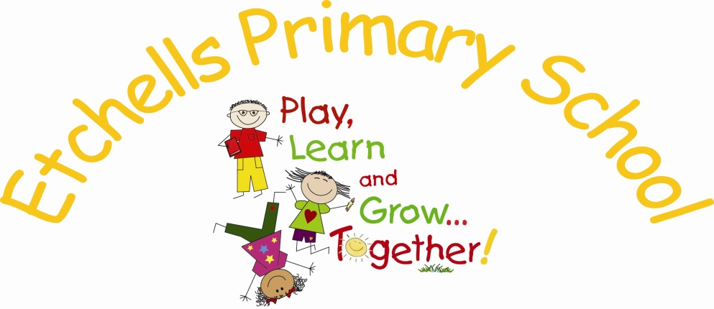

MUSIC
POLICY

March 2018

VERSION HISTORY

Date | Document Version | Document Revision History | Document Author/Reviser
March 2018 | 1.0 | Policy prepared ready for 24th April 2018 | S. Richards

The Music Policy outlines the purpose of music, the aims, the strands of learning and progression for success.

Music is a foundation subject in the National Curriculum and as such is a statutory part of every child’s education.
Rationale
Music contributes to the school curriculum by providing a powerful and distinctive form of communication and expression.
Music can change the way children feel, think and act. It affects emotions and moods providing the opportunity for personal expression, reflection and emotional well-being.
Music is an integral part of culture past and present.
The teaching of music deepens and extends everyday experiences, providing new opportunities and forging important links between the home, the school and the outside world.

Music is a universal language that embodies one of the highest forms of creativity. A high-quality music education should engage and inspire pupils to develop a love of music and their talent as musicians, and so increase their self-confidence, creativity and sense of achievement. As pupils progress, they should develop a critical engagement with music, allowing them to compose, and to listen carefully to a wide range of music.

Aims
The National Curriculum for music aims to ensure that all pupils:
- perform, listen to, review and evaluate music across a range of historical periods, genres, styles and traditions, including the works of the great composers and musicians
- learn to sing and to use their voices, to create and compose music on their own and with others, have the opportunity to learn a musical instrument, use technology appropriately and have the opportunity to progress to the next level of musical excellence
- understand and explore how music is created, produced and communicated, including through the interrelated dimensions: pitch, duration, dynamics, tempo, timbre, texture, structure and appropriate musical notations

Our aims are:
- To provide a rich and balanced framework in which every child’s abilities can be realised and developed.
- To promote enjoyment and aesthetic appreciation of music and developing a range of skills so that pupils become confident enough to communicate their ideas within music:
- listening
- singing
  - composing
  - performing
  - appraising

- To develop attitudes and attributes that can support learning in other subject areas and that are needed in life, for example listening skills, creativity, the ability to concentrate, intuition, aesthetic sensitivity and self-confidence.
- To adopt a cross-curricular approach in which children can express their creativity.

EYFS
For Early Years Foundation Stage, Music comes under the umbrella of ‘Expressive arts and design’. For details, refer to the EYFS STATUTORY FRAMEWORK 2017.
Expressive arts and design involves enabling children to explore and play with a wide range of media and materials, as well as providing opportunities and encouragement for sharing their thoughts, ideas and feelings through a variety of activities in art, music, movement, dance, role-play, and design and technology.
In the early years, music can aid memory by helping the children to remember the alphabet, numbers and other sequences through songs and chants.
KS1 | KS2
Pupils should be taught to:  - use their voices expressively and creatively by singing songs and speaking chants and rhymes  - play tuned and untuned instruments musically  - listen with concentration and understanding to a range of high-quality live and recorded music  - experiment with, create, select and combine sounds using the  inter-related dimensions of music. | Pupils should be taught to sing and play musically with increasing confidence and control.  They should develop an understanding of musical composition, organising and manipulating ideas within musical structures and reproducing sounds from aural memory.  Pupils should be taught to:  - play and perform in solo and ensemble contexts, using their voices and playing musical  - instruments with increasing accuracy, fluency, control and expression  - improvise and compose music for a range of purposes using the inter-related  - dimensions of music  - listen with attention to detail and recall sounds with increasing aural memory  - use and understand staff and other musical notations  - appreciate and understand a wide range of high-quality live and recorded music drawn  - from different traditions and from great composers and musicians  - develop an understanding of the history of music.

Strands of Learning

By the end of each year group, pupils are expected to know, apply and understand the skills and processes specified in the relevant programmes of study in the online Charanga Musical School scheme from Reception to Year 6: listen & appraise, games, singing, playing instruments, improvisation, composition and perform and share.

