Etchells Primary School Overview
Pupil Premium Lead: |  |  |  | Governor Lead: |  | Statement authorised by:
Pete Cope |  |  |  | None |  | Cathy Beddows
Academic Year | 2022/23 |  | Date of most recent review |  | January 2023 | Date for next internal review of this strategy |  | July 2023
Total Number of pupils |  | 381 |  |  | Proportion of pupils eligible for PP |  | 17%
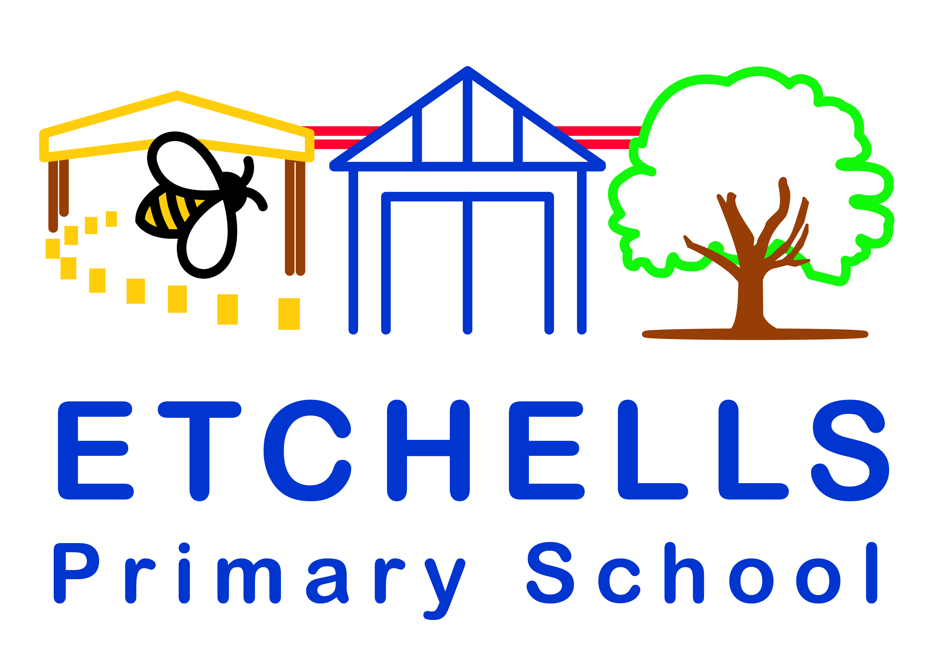

Funding Overview
Pupil premium funding allocation this year | £93,045 (£1345 per child) | Recovery premium funding allocation this year | £0
Pupil premium funding carried forward from previous year | £0 | Total budget for this academic year | £93,045
Statement of intent
At Etchells Primary School, we aim to strategically use pupil premium funding to offer additional support to ensure all children access our core values- Know, Explore and Communicate to reach their full potential.
Our pupil premium strategy supports initiatives that benefit our wider cohort of PP students, such as: well-being, cultural capital, dedicated teaching groups, attendance as well as targeted programmes based on internal data, to identify barriers to learning. This is reviewed termly to ensure money is used effectively and continues to work towards overcoming these.
Challenges
1 | The attendance of the Pupil Premium children is currently 92.27% but needs to be more inline with the non PP children which is 93.18%. Both to be improved.
2. | Reading in Year 2 PP is below average (10%) and Maths in Year 3 is 28%, these are both lower than the Non-Pupil Premium children.
3 | The combined scores for RWM for Y1-3 are below average, which is less than the Non-Pupil Premium children.
4 | Social and emotional wellbeing, which can hinder children’s progress.
Intended outcome |  | Success criteria
PP students to reach our whole school benchmark for attendance. |  | Attendance of PP cohort 95% + July 2023.
Sessions with allocated Wellbeing teacher to address anxiety and wellbeing |  | Identified children to become more confident and are able participate in a range of learning opportunities. Measurable SMART goals (Specific, Measurable, Achievable, Realistic and anchored within a Time Frame) are used that are then evaluated these are specific to each child’s individual concerns.
To address the reading attainment and maths attainment in targeted Year Groups through intervention teaching |  | Through small group and targeted interventions. Focusing on the Arithmetic skills of the children and then applying them to the Reasoning based questions.
To look at the child’s progress across their core subjects, ensuring they meet in RWM. |  | Interventions to take place during school time focusing on the area that the children need to develop. Children have been targeted by assessment lead for class teacher’s to either place in intervention or be a target child for the class.

Activity in this academic year
Teaching Activity | Evidence | Challenge number addressed |  | Budgeted cost:  £
Quality first teaching and outstanding knowledge rich curriculum- to support PP students. | Aspirational projections set at the beginning of the school year.  Projections analysed and discussed during pupil progress meetings and phase meetings. PP Lead to monitor books and support given.  Class teacher to use NFER tests in both Maths and Reading and supported writing tasks, which are assessed against ARE statements. Next steps are identified by the class teacher and are discussed during Pupil Progress Meetings. | 2,3
All staff to know PP and their needs and support them effectively in lessons. | PP identified by class teachers during pupil progress meetings. As part of the Teaching Assistant appraisals, they have identified PP children that they are going to work with. | 2,3
Targeted academic support  1:1 support/ interventions | Evidence | Challenge number addressed |  | Budgeted cost:  £
4 TAs in KS2 and 3 TAs in KS1 x 15 hours per week to support in English and Maths sessions | Working with targeted groups. Small interventions with highly qualified staff, who work closely with the class teacher. Children identified on a Provision Map.  Revisited work completed in purple pen, to address misconceptions and consolidate learning.  New spelling approach adopted September 2021 (Jane Considine). Raising the profile of direct teaching of spellings and phonics. This is implemented in school but remains a focus for the plan. A careful analysis of their NFER scores by teachers and those supporting the PP children. | 2,3,4 |  | £64,463
4 TAs (1 in each key phase) 90 minutes every afternoon | Addressing individualised barriers to learning as identified by the class teacher, where applicable, to complete any SEN support targets. | 2,3,4 |  | £18,412
Wider strategies  Attendance/ well being/ behaviour | Evidence | Challenge number addressed | Budgeted cost:  £
Attendance rates are closely tracked.  Whole school wellbeing strategies are promoted through curriculum activities and small intervention group sessions. | Mrs Hogan tracks attendance daily and follows up any concerns with a member of SLT or EWO. Attendance to increase from 92.27% to 95%  An increase in children’s self-confidence, self-esteem, concentration and behaviour and mental health. Shown through behaviour records, Star of the Week awards recognise mental health achievements, pupil voice to capture self-confidence and self esteem | 1 | £2400
Well-being of these children to be closely monitored.  Referrals given to well-being lead if there is an issue with the child’s mental health. | Mrs Vedvik is the well-being lead of the school. She will take referrals and plan accordingly; this may be in a small group intervention or on a 1:1 basis.  This is completed so that the children can regulate their emotions more effectively, reduce anxiety levels etc. | 4 | £3942
Resources and equipment for PP children. | Any equipment needed to support learning e.g. work books, uniform, laptops etc. |  | £1400
Allocation of monies for trip subsides including residential | Financial support is giving to parents for the payment of trips |  | £2600
Total budgeted cost |  | £93, 027
Pupil Premium Strategy outcomes
PP students to reach our whole school benchmark for attendance.
Mrs Hogan has looked at all the attendance of the PP children this year. The benchmark for the school was 94%, which is the national average. Last year, The attendance of the Pupil Premium children was 92.27% but needed to be more in line with the non PP children which was 93.18%. Currently the attendance for PP children is 89.15% which is lower than last year. However, there are a few children who have joined that the attendance has impacted on the whole figure with one being as low as 35%. This will continue to be a priority for next year.
Sessions with allocated Wellbeing teacher to address anxiety and wellbeing
Through pupil progress meetings, the pupil premium children were discussed and any that needed support with their emotional wellbeing. These children have been referred to our wellbeing lead to complete sessions with them. A number of families have also been discussed at TAS meetings to support families.
To address the reading attainment and maths attainment in targeted Year Groups through intervention teaching
Last year, reading in Year 2 PP was below average (10%) and Maths in Year 3 was 28%, these are both lower than the Non-Pupil Premium children. This year, during the appraisal cycle the DHT has asked the TAs to name a number of PP children that they would do work with over the course of the year. These children were discussed with both teachers and teaching assistants during pupil progress meetings. The cohort of children in Year 2 PP that was at 10% is now at 56%, however, this is still at 23% gap to non PP children. The year 3 children, now in Year 4 have increased to 79% through interventions. There is still a gap with non PP children.
To look at the child’s progress across their core subjects, ensuring they meet in RWM.
RWM for Year 1-3 has increased by 10% since last year. This is becoming more online with our non PP children. This was closely monitored in pupil progress meetings.

Next year as part of the plan, all PP children will have a planning sheet that will detail interventions that they are taking part in and the data will be inputted every term. The teaching assistants will still have PP children as part of their appraisal targets.
Externally provided programmes
Programme | Provider
Residential subsidised for Pupil Premium children for Year 5/6 children. | YHA/Robinwood.

