Geography Skills
Expected by End of Year 1
Locational and Place Knowledge | Fieldwork
- I understand geog. similarities and differences through studying the human & physical geography of a small area of the UK.  - I can identify capital cities in the UK. | - I can use simple fieldwork and observational skills to study the geography of my school and its grounds.  - I use first hand observation to investigate places - the  - School grounds, the streets around and the local area.
- Use of Basic Geographical Vocabulary | - Using Globes, Maps and Plans
- I use and understand basic geographical specific vocabulary relating to human and physical geography  - I can use these specific key vocabulary to describe physical features (beach, cliff, coast, forest, hill, mountain, sea, river, soil, season, weather)  - key human features (city, town, farm, house, port, harbour, shop, address)  - I can use mathematical vocabulary to describe position and location. | - I use world maps, atlases and globes to identify UK & its countries  - I can use aerial photographs and plan perspectives to recognise landmarks and basic human and physical features.
- Map Work Skills | - Human and Physical Geography - enquiry skills and communication
- I can use simple compass directions (NSEW)  - I can use locational and directional language (e.g. near and far; left and right) to describe the location of features and routes on a map.  - I am beginning to use & construct basic symbols in a key  - I can make a simple map (e.g. from a story). | - I can identify seasonal/ daily UK weather patterns  - I begin to explain how/why  I can find information from aerial photographs  - I can use observational skills and ask and respond to questions.  - I can study the key human and physical features of the surrounding environment of my school.
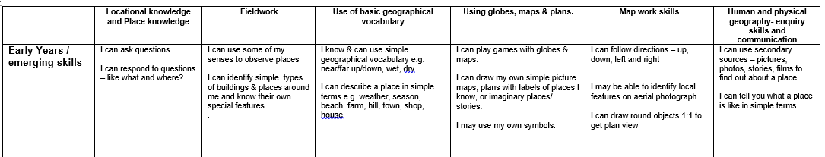

Geography Assessment
Expected by End of Year 1
Locational and Place Knowledge |  | Fieldwork
Below Expectation | Above Expectation | Below Expectation | Above Expectation
Use of Basic Geographical Vocabulary |  | Using Globes, Maps and Plans
Below Expectation | Above Expectation | Below Expectation | Above Expectation
Map Work Skills |  | Human and Physical Geography - enquiry skills and communication
Below Expectation | Above Expectation | Below Expectation |  | Above Expectation

