What are Reading Vipers?
These are the key reading skills for children to be able read and comprehend a wide range of literary texts.
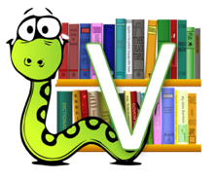 | Vocabulary  Looking at the choice of words that an author uses in a text.
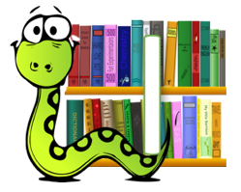 | Infer  What is suggested but not said in the text? Read between the lines and find the ‘hidden’ meaning.
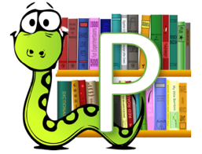 | Predict  What might happen next based on what has happened in the text?
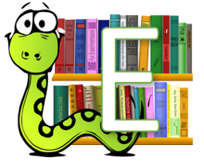 | Explain  Explain an aspect of the text. This may include why the author includes it.
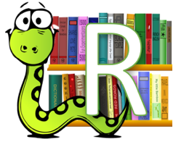 | Retrieve  Retrieve information from the text to answer questions.
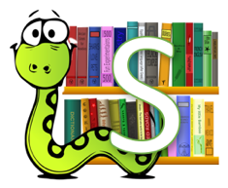 | Summarise  Sum up key points in the text or sequence events as a summary.

How can I support my child with their
reading comprehension at home?
You could try one or more of these activities at home with your child when you hear them read at home.
Vocabulary
Pick out two or three words from the text they have read and use the passage to discuss their meaning.
Talk about other words that have the same meaning.
Infer
Discuss a character’s personality or feelings – ask your child “how do you know this?” See if they can spot something that is suggested but not said e.g. “the boy’s hands were trembling” – we can infer that he might be nervous.
Predict
At the end of the chapter, encourage your child to make a prediction about what might happen next, based on what they know.
Explain
Pick an event from the chapter and encourage your child to explain and why they think it might be included. Find a phrase or word and discuss why the author used it – what effect does it have on the reader?
Retrieve
See if your child can retrieve key information from the chapter you’ve read with them e.g. names/ details/ events.
Summarise
At the end of the chapter/pages – see if your child can sum up the key points of what they have just read.

