Version History

Date: | Document Version | Document Revision History | Document Author/Reviewer
13.2.2015 | 2.1 | Document drafted | H Moorcroft  S Wilson  J Mallinson
25.2.2015 | 2.1 | Staff meeting to formulate addition and subtraction sections of policy | S Wilson  J Mallinson in conjunction with all staff
11.3.2015 | 2.1 | Staff meeting to look at multiplication section and review the contents of the addition and subtraction sections | S Wilson  J Mallinson in conjunction with all teaching staff
18.3.2015 | 2.1 | Division section discussed | S Wilson  J Mallinson in conjunction with all teaching staff
20.5.2015 | 2.1 | Policy placed before teaching staff to check it and discuss ARE statements (Appendix B)for September 2015

Contents
Pages
1 | Version History
3 | Policy Statement
4 | Aims of the Calculation Policy
5-11 | Addition
12-17 | Subtraction
18-24 | Multiplication
25-30 | Division
Appendix A | Etchells Way maths
Appendix B | ARE statements for each Year group

Policy Statement
This policy outlines approaches to mental and written calculations taught at Etchells School from Years 1-6. It is designed to ensure consistency and progression of learning when using and applying the four rules of number.
This policy has been formed with the staff of Etchells Primary, as a result of changes to the Maths National Curriculum2014. The three main aims of the curriculum are to develop pupils’ fluency, reasoning and problem solving.
The calculation policy is organised according to Age related ‘performance descriptors’ as set out in the National Curriculum 2014, however all pupils will be taught according to the stage they are currently working at, moving on when they are secure.
Children should secure mental strategies and rapid recall of facts e.g. by Year 4 children are expected to accurately recall the multiplication facts up to 12 x 12.
The policy outlines written methods for addition, subtraction, multiplication and division that will be taught in each year group. Calculations that require a written method will be presented to the children with a wide variety of models and images, such as number lines, counters and interactive resources. There is an emphasis on children articulating, explaining and justifying methods and strategies they have used.

Aims of the calculation policy
To ensure a consistent approach to the presentation, teaching and learning of mental and written calculations.
To strengthen progression in children’s understanding and application of a range of methods.
To build on the use of models and images introduced, in order to promote conceptual understanding and fluency.
To provide guidance to teaching staff, teaching assistants and parents.

Year 1 Addition
Objective | Method | Model/ Examples
Read, write and interpret mathematical statements involving addition (+), subtraction (–) and equals (=) signs  Represent and use number bonds and related subtraction facts within 20  Add and subtract one-digit and two-digit numbers to 20, including zero  Solve one-step problems that involve addition and subtraction, using concrete objects and pictorial representations, and missing number problems such as 7 = – - 9. | Introduction to + = signs and missing number calculations  Pupils will learn the concept of equality before using the = sign.  Missing numbers will be presented to pupils in all possible places.  3 + 4 = __ __ = 3 + 4  3 + __ = 7 7 = __ + 3  *Pupils will be taught that addition is commutative, so if we know  3 + 4 = 7 we also know 4 + 3 = 7  2 sets of objects will be combined (aggregation) before pupils progress to adding on from the larger number (augmentation).  Mental calculations  Children will be plenty of opportunities to embed knowledge of complements to 10 and doubles of numbers to 10.  They will be expected to count on and back to increasingly large numbers and know what one more/1 less than a given number is. | 1+2=3  3 =1+2  1+4 = 3+2  Combine 2 sets of numbers  7  4 3  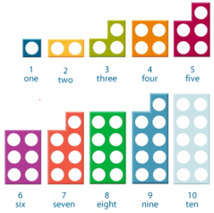  Use numicon and visual images to support the visualisation of number facts  A number track will be used to help pupils to count on in sequence.  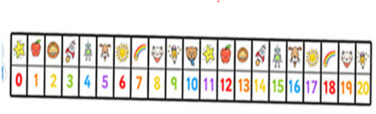  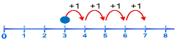  A number line (with models and images as necessary) will be used to develop the concept of augmentation.  3 + 4 = 7

Year 2 Addition
Objective | Method | Model/ Examples
 | Missing number problems  e.g. 13 + 6 = 10 + __  24 + __ + __ = 100  42 = __ + 12  Use base 10 and balance scales to ensure concept of equality is fully embedded.  Count on in tens and ones  24 + 13 = 24 +10 + 3  = 34 + 3  = 37  Partitioning and bridging through tens  Children should use their knowledge of the complements to 10 to count on to the next tens number then add remaining ones. 8 + 7 = 15  Adding 9 or 11 by adding 10 then adjusting by 1  23 + 9 =32  23 + 10 = 33 then take away 1  Towards a written method for TU plus TU  24 + 37 =  Add the ones first then exchange the ten ones for a 10 stick.  Expanded written method  24 + 37 =  20 + 4 + 30 + 7=  20 + 30 + 7 + 4 =  50 + 11 = 61 | continue to use numicon, images and models to support the visualisation of number facts and calculations.  Use 1 digit per square for fractions  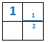  +10 +3  24 34 37  +2 +5  8 10 15  + 10  -1    23 32 33  20 + 4  + 30 + 7  50 + 11
  Solve problems with addition and subtraction:
  - using concrete objects and pictorial representations, including those involving numbers, quantities and measures
  - applying their increasing knowledge of mental and written methods
  Recall and use addition and subtraction facts to 20 fluently, and derive and use related facts up to 100
  Add and subtract numbers using concrete objects, pictorial representations, and mentally, including:
  - a two-digit number and ones
  - a two-digit number and tens
  - two two-digit numbers
  - adding three one-digit numbers
  Show that addition of two numbers can be done in any order (commutative) and subtraction of one number from another cannot
  Recognise and use the inverse relationship between addition and subtraction and use this to check calculations and solve missing number problems.

KS1 Mastery/ exceeding performance descriptors
• All aspects of number - addition and subtraction at the national standard are embedded.
• Recall and use addition and subtraction facts to 20 fluently; derive and use related facts to 100 and beyond.
• Add and subtract numbers mentally using appropriate strategies, including:
o 2 2-digit numbers
o adding /subtracting several single-digit numbers.
• Add and subtract numbers using objects, pictorial representations and the written columnar method including:
o adding several 2-digit numbers
o subtracting 2-digit numbers
o adding a 2-digit number to a 3-digit number
o adding 3-digit numbers.
• Solve missing number problems involving a wider range of numbers.
• Use addition and subtraction facts to solve more complex problems, such as 3 step problems.

Year 3 Addition
Objective | Method | Model/ Examples
Add and subtract numbers mentally, including:  a three-digit number and ones  a three-digit number and tens  a three-digit number and hundreds  Add and subtract numbers with up to three digits, using formal written methods of columnar addition and subtraction  Estimate the answer to a calculation and use inverse operations to check answers  Solve problems, including missing number problems, using number facts, place value, and more complex addition and subtraction. | Missing number problems  Continue to provide equations with 3 digit numbers, that feature missing digits in each possible location and introduce images to represent numbers. 35 + = 67  Partitioning for addition  Partition into hundreds, tens and ones then add each set and recombine.  Move on to retaining the first number and only partitioning the second number.  Introducing a more formal written method  Introduce expanded column addition modelled with base 10 apparatus. Model the exchange of 1s for tens and show this on a written sum.  When children understand the exchange between tens and ones they may begin to form the columnar method shown, which should be discussed and recognised as a more efficient method than the first expanded calculation. 224  The exchanged 10 should be carried below the sum and crossed through when it has been added.  +148  372  1 | 73 + 64 = 200 -  210 + + = 340  42 = 76 -  Children need to be secure in the addition of multiples of 10 and 100 to any number  324 + 248 =  300 + 20 + 4  200 + 40 + 8  500 + 60 + 12 = 572  324 + 200 + 40 + 8  = 524 + 40 + 8  = 564 + 8  Add the units first in preparation for the compact method.  = 572  224  +148    12  60  300  372  move on to

Year 4 Addition
Objective | Method | Model/ Examples
Add and subtract numbers with up to 4 digits using the formal written methods of columnar addition and subtraction where appropriate  Estimate and use inverse operations to check answers to a calculation  Solve addition and subtraction two-step problems in contexts, deciding which operations and methods to use and why. | Missing number problems  Equations with larger numbers up to 4 digits , that feature missing digits in each possible location and expand on the use of balanced equations, where more than one type of calculation is used.  Partitioning for addition  Continue with the expanded form of addition modelled using base 10 cubes, introducing the thousands cube when pupils are ready.  Compact (formal) written addition  Children should be working with numbers up to 4 digits, but should be able to revert back to expanded addition if they are experiencing difficulty with the compact method.  Extend addition calculations to include numbers with up to 2 decimal places.  Use the written method with decimals in the context of money and measure to solve problems. | 73 + 64 = 200  210 + __ + __ = 340  64 ÷ 8 = 2 + __    +     1224  +148  12  60  300  1000  1372  3426  The exchanged digits should be carried below the sum and crossed through when they have been added  +1715  5141  1 1  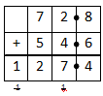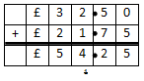  Only use numbers with the same number of decimal places at this stage.  Decimal point on the line – not in a square of its own.

Year 5 Addition
Objective | Method | Model/ Examples
Add and subtract whole numbers with more than 4 digits, including using formal written methods (columnar addition and subtraction)  Add and subtract numbers mentally with increasingly large numbers  Use rounding to check answers to calculations and determine, in the context of a problem, levels of accuracy  Solve addition and subtraction multi-step problems in contexts, deciding which operations and methods to use and why. | Missing number problems  Equations with larger numbers up to 4 digits. Use of algebraic formulae may become more formal in appearance.  Example: 33 = 3N so what must N be?  Mental Methods  Children should continue to develop the use of different methods for addition. They should be given opportunities to explore and discuss ‘which’ are the most efficient strategies and ‘why’- justifying their own points of view and explaining their reasoning.  Formal written addition  Children should now be secure in the use of the compact addition method for whole numbers, working beyond 4 digits.  Base 10 blocks can again be used alongside the columnar algorithm to support those pupils who need the visual representation of decimal numbers.  Children should be using rounding to support them in estimating an answer and should be encouraged to consider how sensible their answer is, particularly when solving problems. | 3464 + 1998 =  3464 + 2000 = 5464  5464 – 2 = 5462  14376 + 2400 =  14367 + 2000 = 16367  16367 + 400 = 16767  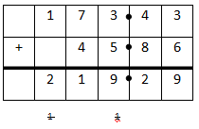  Ensure pupils understand why and how to line up the decimal point when some numbers begin in a different column.  1.48 = 1 . 4 8  25.356 + 346.28 becomes an estimate of 25 + 350 = 375 and this is used to check whether the answer is sensible, once the calculation has been completed.  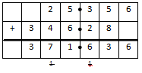

Year 6 Addition
Objective | Method | Model/ Examples
Perform mental calculations, including with mixed operations and large numbers  Use their knowledge of the order of operations to carry out calculations involving the four operations  Solve addition and subtraction multi-step problems in contexts, deciding which operations and methods to use and why  Solve problems involving addition, subtraction, multiplication and division .  Use estimation to check answers to calculations and determine, in the context of a problem, an appropriate degree of accuracy. | Missing number problems  Equations with larger numbers up to 4 digits. Use of algebraic formulae will be more formal in appearance.  Mental methods  Children should continue to develop methods, supported by a range of models and images. Calculations need to be presented in a wide variety of ways, with mixed operations and children should continue to reason and explain their choices of strategy, looking for efficiency.  Formal written addition  As in year 5 but progressing to larger numbers including those with up to three decimal places. The aim should be for conceptual understanding and procedural fluency with column addition secure with both whole numbers and decimal calculations. Integers should have different numbers of digits so that pupils secure their knowledge of place value when calculating.  Pupils should continue to have opportunities to apply their knowledge in a variety of contexts. Addition calculations should be provided with different numbers of decimal places (including money and measures) | 33 = 3N + 15 so what must N be?  ( + ) x = 10 (where the answer is no longer a whole number)  149 + 137 – 158 =  12462 + 8456  Estimate: 12500 + 8500 = 21000  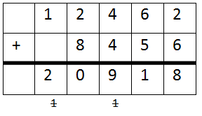  23.361 + 9.08 + 59.77 + 1.3  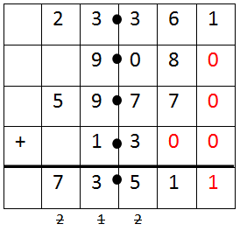  Empty decimal places should be filled with a zero to show that there is no value to add and to retain place value for all other digits.

Year 1 Subtraction
Objective | Method | Model/ Example
Represent and use number bonds and related subtraction facts within 20  Add and subtract one-digit and two-digit numbers to 20, including zero  Solve one-step problems that involve addition and subtraction, using concrete objects and pictorial representations, and missing number problems such as 7 = – 9.  Read, write and interpret mathematical statements involving addition (+), subtraction (–) and equals (=) signs | Images and practical apparatus, such as numicon, multilink cubes and Deins cubes among others, will be used to model the process of subtraction.  Subtraction is the inverse of addition  As pupils begin to build on their knowledge of number bonds to 10/20, they will be taught that this knowledge enables them to solve subtraction calculations too.  6 + 4 =10 so 10 – 6 = 4  They will be taught that subtraction is not commutative.  (10 – 6 = 4 but 6 – 10 is not 4)  Missing number problems  Pupils will be shown that they can work out missing numbers using knowledge of bonds.  10 - ___ = 3  10 – 7 = 3 because 7 + 3 = 10  Practical apparatus and, later, number lines, will be provided to enable pupils to ‘count back’.  The language of ‘find the difference’ and ‘how many more/less than’ will be experienced in a range of practical contexts. |   Count back in 1s on a numbered line to take away with numbers up to 20  __= 8 – 3 8 – 3 = __  5 = __ - 2 __- 2 = 8  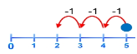  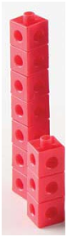  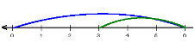  The difference between 7  And 3 is 4

Year 2 Subtraction
Objective | Method | Model/ Example
Solve problems with addition and subtraction:  - using concrete objects and pictorial representations, including those involving numbers, quantities and measures  - applying their increasing knowledge of mental and written methods  Recall and use addition and subtraction facts to 20 fluently, and derive and use related facts up to 100  Add and subtract numbers using concrete objects, pictorial representations, and mentally, including:  - a two-digit number and ones  - a two-digit number and tens  - two two-digit numbers  - adding three one-digit numbers  Show that addition of two numbers can be done in any order (commutative) and subtraction of one number from another cannot  Recognise and use the inverse relationship between addition and subtraction and use this to check calculations and solve missing number problems. | Pupils will be taught first to count back in 1s, then in 10s, then in a combination of 10s and 1s, using practical apparatus e.g. Deins, the 100 number line or 100 square as a guide, before counting back in near 10s such as counting back 9 or 11 by using ‘adjusting’.  A wider range of - vocabulary will be investigated.  Subtraction is the inverse of addition  The 2 rules will continue to be taught together, with children using practical apparatus to investigate related addition and subtraction facts. 4  4 + 6 =12 so 12 – 6 = 4  *The calculation can come both before and after the = symbol.  12 – 4 = 6 so 6 = 12 – 4  *Subtraction is not commutative  Missing number problems  Calculations will now be presented in different ways, using numbers up to, and beyond, 100 as appropriate.  45 = 56 - ____ 0r 48 - ___ = 23  Towards written methods  Expanded columns (initially without decomposition) will be used to support understanding of place value, in preparation for more efficient written calculations. | 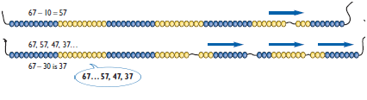  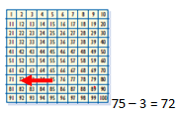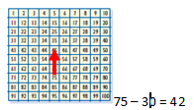  Ensure pupils can count on and back in 1s and 10s confidently.  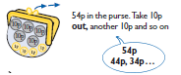  Tens ones  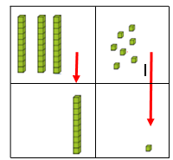  Introduce this method before introducing exchanging  40 8  -10 1  30 8

Year 3 Subtraction
Objective | Method | Model/ Example
Add and subtract numbers mentally, including:  a three-digit number and ones  a three-digit number and tens  a three-digit number and hundreds  Add and subtract numbers with up to three digits, using formal written methods of columnar addition and subtraction  Estimate the answer to a calculation and use inverse operations to check answers  Solve problems, including missing number problems, using number facts, place value, and more complex addition and subtraction. | Subtraction is the inverse of addition  Pupils will be taught +/- at the same time and will be encouraged to use addition to check the answers to their subtraction calculations.  Mental calculations  Pupils will be reminded to use partitioning to count back/on in hundreds, then tens, then in 1s or vice versa. Models and images will support their understanding. They may choose to use complimentary addition or counting back and should be given opportunities to discuss ‘efficiency’.  Missing number problems  As for Year 2 but with progressing to larger numbers.  Written methods (progressing to 3 digits)  Pupils will revise expanded column addition (from Year 2) with no decomposition, then begin to investigate decomposition using Deins cubes.  When children are secure with the above method they should compare this with written method.  Solving problems  Children will practise the different methods learnt, in problem solving contexts, and discuss ‘efficiency’ by comparing their chosen methods. | 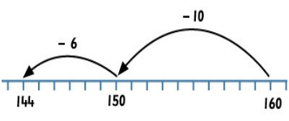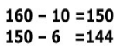  H T 1s  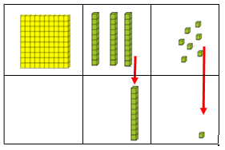  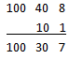  When introducing ‘exchange’ ensure pupils explore different ways to partition so the value remains the same. 84 = 80 + 4 = 70 + 14 = 60 + 24 etc. emphasise the value doesn’t change, we have just split the number in different ways.  Model decomposition  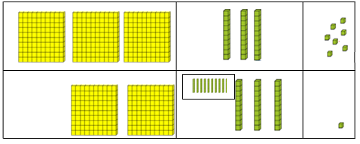  300 30 7 becomes  200 130 7  2  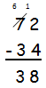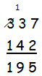  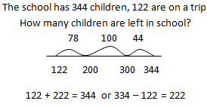

Year 4 Subtraction
Objective | Method | Model/ Example
Add and subtract numbers with up to 4 digits using the formal written methods of columnar addition and subtraction where appropriate  Estimate and use inverse operations to check answers to a calculation  Solve addition and subtraction two-step problems in contexts, deciding which operations and methods to use and why. | Subtraction is the inverse of addition  Use addition to check the answers to subtraction calculations.  Mental calculations  Children should continue to develop methods for subtraction of larger numbers and use jottings to record parts of calculations. They may again choose to do complimentary addition or subtraction of near tens/hundreds among other methods and should be given opportunities to look at efficiency.  Missing number calculations  Problem solving, reasoning and fluency is developed through the continued use of these calculations. Children should now be confident in explaining the strategies they have used.  Written methods (progressing to 4 digits)  Column subtraction with decomposition should be secured in Year 4, modelled to begin with by the use of Deins cubes.  Children should estimate answers using their rounding knowledge. | Use 319 + 137 to check of the calculation  456 – 137 = 319 is correct.  947 – 198 is best completed by taking away 200, then adjusting rather than a formal calculation.  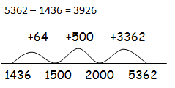  563 + __ = 724 34 + 56 + __ = 243  450 – 30 – 65 - __ = 160  __ - 570 = 1000 458 – 56 = 540 - __  They should estimate answers before completing calculations.  (5300 – 1500 = 3800)  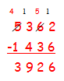  Pupils should be given opportunities to compare different methods and discuss which are the most efficient.

Year 5 Subtraction
Objective | Method | Model/ Example
Add and subtract whole numbers with more than 4 digits, including using formal written methods (columnar addition and subtraction)  Add and subtract numbers mentally with increasingly large numbers  Use rounding to check answers to calculations and determine, in the context of a problem, levels of accuracy  Solve addition and subtraction multi-step problems in contexts, deciding which operations and methods to use and why. | Subtraction is the inverse of addition  Consistently use addition to check the answers to subtraction calculations.  Mental calculations  Use jottings as standard to record parts of mental calculations. They may again choose to do complimentary addition or subtraction of near tens/hundreds (with adjusting) among other methods and should explain their methods and the reasons for their choices.  Missing number calculations  Problem solving, reasoning and fluency is developed through the continued use of these calculations. Children should now be confident in explaining, and in justifying, the strategies they have used.  Written methods (progressing to more than 4 digits)  Calculations should now begin to include decimal numbers, including those with a mixture of integers. Pupils should align the decimal point, recognising it as a ‘place holder’.  Children will be given lots of opportunities to subtract and find differences with money and a variety of measures. | 1 4 3 6  + 3 9 2 6  5 3 6 2  1 1  1342 – 1290 =  could be completed by doing  1342 – 1300 = __then adjusting by 10 or by counting on from 1290 to 1342 – which is the better method?  6.45 = 6 + 0.4 + __  119 - __ = 86  100000 - __ = 99,999  12463 – 2300 = __  1345 – 274 = 1450 - __  If we buy three items at £2.99 each how much change could we get from a £20 note?  3 x £3 = £9.00 then adjust by taking away 3p £8.97 before calculating the change.  Add a zero to any empty decimal places to aid understanding of place value  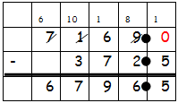

Year 6 Subtraction
Objective | Method | Model/ Example
Perform mental calculations, including with mixed operations and large numbers  Use their knowledge of the order of operations to carry out calculations involving the four operations  Solve addition and subtraction multi-step problems in contexts, deciding which operations and methods to use and why  Solve problems involving addition, subtraction, multiplication and division .  Use estimation to check answers to calculations and determine, in the context of a problem, an appropriate degree of accuracy. | Subtraction is the inverse of addition  Consistently use addition to check the answers to subtraction calculations.  Mental calculations  Use jottings as standard to record parts of mental calculations. Explain their methods and fully justify the reasons for their choices.  Missing number calculations/algebra  Children in Year 6 should be using calculations with mixed operations.  Written methods  Calculations should continue to include decimal numbers, including those with a mixture of integers. Pupils should align the decimal point, recognising it as a ‘place holder’. The aim should be for both conceptual understanding and procedural fluency.  Solving problems  Children should use estimation and use inverse calculations to check validity of answers. They will continue to be given lots of opportunities to subtract and find differences in multistep problems. | and each stand for a different number  = 42  + = + +  What is the value of ?  What if = 74? Or = 126  What if is 57? (where the answer will be a decimal number)  10 000 000 = 9 000 100 + __  7 -2 x 3 = __  (7 – 2) x 3 = __  (__ - 2 )x 3 = 15  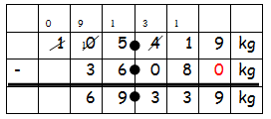  Add a zero to empty decimal places to aid understanding of place value.

Year 1 Multiplication
Objective | Method | Model/ Example
 | Multiplication is the same as repeated addition  Use repeated addition to show how multiplication is related to doubling.  Count on in steps of the same size using practical resources such as washing line, numicon, bead strings, and later number lines.  Introduction to vocabulary  Learn the vocabulary of ‘times’ ‘lots of’ ‘groups of’ ‘sets of’ in very practical ways to develop conceptual understanding.  Begin to use arrays to understand that multiplication can be done in any order (commutative)  Pupils to practise counting on in 2s, 10s then begin to use 5s. | How many legs will three people have?   2 + 2 + 2 = 6    There are three sweets on one plate, how many sweets would be on four plates. 3 + 3 + 3 + 3 = 12  2 lots of 3 = 6  or 3 sets of 2 = 6  or 6 = 2 groups of 3  or 6 = 3 x 2
  Solve one-step problems involving multiplication and division, by calculating the answer using concrete objects, pictorial representations and arrays with the support of the teacher.

Year 2 Multiplication
Objective | Method | Model/ Example
Recall and use multiplication and division facts for the 2, 5 and 10 multiplication tables, including recognising odd and even numbers  Calculate mathematical statements for multiplication and division within the multiplication tables and write them using the multiplication (×), division (÷) and equals (=) signs  Show that multiplication of two numbers can be done in any order (commutative) and division of one number by another cannot  Solve problems involving multiplication and division, using materials, arrays, repeated addition, mental methods, and multiplication and division facts, including problems in contexts. | Arrays and number lines  Develop understanding of multiplication, by making the links with repeated addition and discussing efficiency. Make use of visual images and practical apparatus. Later begin to include tables other than 2x, 5x and 10x. A range of vocabulary should be used to ensure pupils are familiar with common terms related to x. (pupils should know the 2x, 5x and 10x tables by the end of Year 2)  Express multiplication using the symbol x  Look at arrays and begin to record what they show, using simple written format. Record different ways of explaining the same array, noting that the calculation can come both before and after the = symbol (and investigate commutative law). Use this knowledge to solve missing number problems.  Pupils should be confidently counting on in steps of 2, 5 and 10 and be able to count on and continue patterns in steps of different sizes.  Towards written methods  They should use jottings to develop understanding of doubling by partitioning of 2 digit numbers.  Investigate and learn 2x 50 = 4 x 25 = 5 x 20 = 10 x 10 =100 | 5 x 2 = __ __ = 5 x 2  5 x __ = 10 10 = 2 x __  10 = __ x 5 2 x __ = 10  4 x 3 = 12  3 x 4 = 12  3 x 4 = 4 + 4 + 4  4 x 3 = 3 + 3 + 3 + 3  +5 +5 +5 +5 +5  0 5 10 15 20 25  Double 3 is 6  2 x 3 = 6  14  10 4  X2 x2  20 8  28

Mastery/ exceeding in Number - multiplication and division
• All aspects of number – multiplication and division at the national standard are embedded.
• Rapidly recall and use multiplication and division facts for the 2, 5 and 10 multiplication tables and write mathematical statements using the multiplication (×), division (÷) and equals (=) signs.
• Count in 3s to solve multiplication and division problems for the 3 multiplication table.
• Solve more complex problems involving multiplication and division in a range of contexts including measures.
• Make connections between place value and multiplication/division by 10 and use known multiplication and division facts to derive others.

Year 3 Multiplication
Objective | Method | Model/ Example
. | Mental Methods  Pupils should know and use 2x, 5x and 10x table in a range of contexts. Double TU by partitioning, recording the steps using jottings as necessary.  Initially they should use their knowledge of 2x tables to find 4x and 8x table quickly. (Pupils should have instant or rapid recall of 2x, 3x, 4x, 5x, 8x and 10 x tables by the end of Year 3).  Missing number problems  These should be used to develop pupils’ fluency reasoning and problem solving skills.  Written methods (TU x U)  Develop understanding of written methods by using arrays to model the partitioning and multiplication of T then U.  Introduce the grid method alongside the array to represent the calculation. Children should discuss efficiency and recognise the link between the image and the grid written method. |   5 set of 5 =25  34  30 4  X2 x2  60 8  68  Remind pupils that multiplication is commutative – the numbers in the calculation can be reversed.  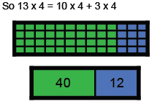  40 + 12 = 52
  Recall and use multiplication and division facts for the 3, 4 and 8 multiplication tables
  Write and calculate mathematical statements for multiplication and division using the multiplication tables that they know, including for two-digit numbers times one-digit numbers, using mental and progressing to formal written methods
  Solve problems, including missing number problems, involving multiplication and division, including positive integer scaling problems and correspondence problems in which n objects are connected to m objects.
  6 x 4 = 24
  4 x 6 = 24
  x | 10 | 3
  4 | 40 | 12

Year 4 Multiplication
Objective | Method | Model/ Example
Recall multiplication and division facts for multiplication tables up to 12 × 12  Use place value, known and derived facts to multiply and divide mentally, including: multiplying by 0 and 1; dividing by 1; multiplying together three numbers  Recognise and use factor pairs and commutativity in mental calculations  Multiply two-digit and three-digit numbers by a one-digit number using formal written layout  Solve problems involving multiplying and adding, including using the distributive law to multiply two digit numbers by one digit, integer scaling problems and harder correspondence problems such as n objects are connected to m objects. | Mental Methods  Count on in steps of 6, 7, 9, 25 and 50. Use knowledge of 3x to find 6x by doubling.  Solve practical problems using jottings of known number facts to find others.  By the end of Year 4 pupils are expected to know all tables facts to 12 x 12. Investigate factors and multiples. Investigate and begin to explain what happens when numbers are x by 10/100/1000  Missing number problems.  Presented in a variety of different ways with pupils being encouraged to rearrange calculations so they can use known facts to find missing digits and integers.  Written methods (progressing to TU and HTU x U)  Children to continue to use grid method (with arrays to show visual representation if still needed). When ready children to move to expanded method multiplying unit first.  Compact method  When confident , move to the use of formal method for TU x U then HTU x U. Unit column also to be referred to as ‘ones’ column. | __ x 5 = 160 18 x __ = 72  120 = ___ x 20 120 = 20 x __  Use commutativity and other strategies.  4 x 6 = 6 x __  2 x 6 x 5 = 10 x __  __ x 7 = (30 x 7) + (9 x 7)  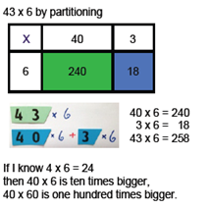  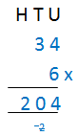  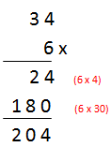  Move to short multiplication when children confident with carrying

Year 5 Multiplication
Objective | Method | Model/ Example
Identify multiples and factors, including finding all factor pairs of a number, and common factors of two numbers  Know and use the vocabulary of prime numbers, prime factors and composite (non-prime) numbers  Establish whether a number up to 100 is prime and recall prime numbers up to 19  Multiply numbers up to 4 digits by a one- or two-digit number using a formal written method, including long multiplication for two-digit numbers  Multiply and divide numbers mentally drawing upon known facts  Divide numbers up to 4 digits by a one-digit number using the formal written method of short division and interpret remainders appropriately for the context  Multiply and divide whole numbers and those involving decimals by 10, 100 and 1000 | Mental methods  Pupils to solve problems involving scaling up/down. ‘Class Discussions’ to ensure pupils are relating each calculation to known number facts and making links. Pupils should : know prime numbers to 19 and be able to work out if another number o 100 is/is not prime; Know what happens to numbers when they are x by 10/100/1000.  Investigate and become familiar with square and cubed numbers.  Written methods (beginning to calculate TU x TU)  Continue to use grid method until pupils are ready to move to compact method.  Missing number problems  As for Year 4 but with increasingly large numbers.  Long multiplication  When children fully understand place value and are confident with carrying over in HTU x U calculations, they may move on to formal long multiplication. | 4 x 35 = 2 x 2 x 35, 8 x 35 = 2 x 2 x 2 x 35  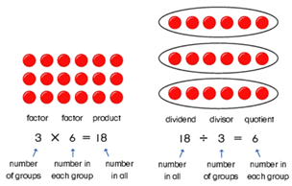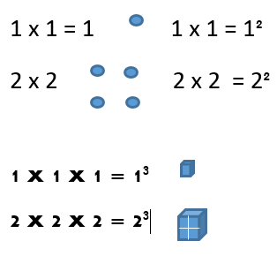  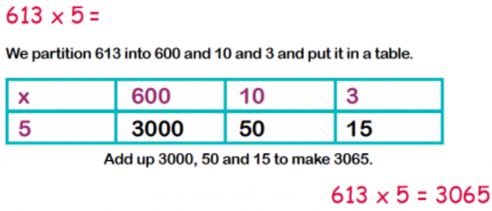  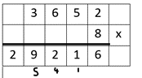  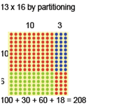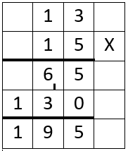

Year 6 Multiplication
Objective | Method | Model/ Example
Multiply multi-digit numbers up to 4 digits by a two-digit whole number using the formal written method of long multiplication  Divide numbers up to 4 digits by a two-digit whole number using the formal written method of long division, and interpret remainders as whole number remainders, fractions, or by rounding, as appropriate for the context  Divide numbers up to 4 digits by a two-digit number using the formal written method of short division where appropriate, interpreting remainders according to the context  Perform mental calculations, including with mixed operations and large numbers  Use their knowledge of the order of operations to carry out calculations involving the 4 operations.  Use estimation to check answers to calculations and determine, in the context of a problem, an appropriate degree of accuracy. | Mental Methods  Children continue to solve practical problems involving scaling up or down. They explore the order of operations and the use of brackets, investigating whether the position affects the answer.  Written methods  Some pupils may continue to use grid method for calculation until confident.  Others will continue to practise and refine skills of formal multiplication and long multiplication.  Short multiplication for decimals  Use short multiplication to x a decimal number with up to 3 DP by a single digit number. Complete problems involving units of measure. | A bag of 4 oranges cost 37 pence. How much do 12 orange cost?  A bag of four apples cost 36 pence how much would 6 apples be?  2 + 1 x 3 = 5 and (2 + 1) x 3 = 9 children to discuss and explain how both calculations could be correct.  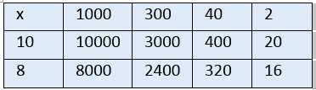  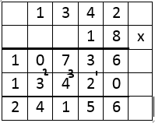  The decimal point does not have a value and therefore doesn’t sit in a square on its own.  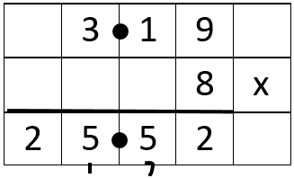

Year 1 Division
Objective | Method | Model/ Example
 | Make direct links to multiplication when teaching division.  Introduction to grouping and sharing should involve practical activities using small numbers to support pupils in developing an understanding of the difference between the 2 concepts.  Grouping  Children should use practical apparatus and arrays as pictorial representations for division.  12 ÷ 2 = 6  So 12 ÷ 6 = 2  They should investigate halves and quarters finding simple fractions of objects, quantities and numbers.  Half of 10 is 5  10 ÷ 2 = 5  Pupils may have the ÷ symbol modelled and HA pupils may begin to use it in their recording of the results of practical activities.  Sharing  Use concrete apparatus to share items equally, developing the concept of 1:1 correspondence.  6 shared into 2s is 3  8 shared between 2 is 4 | How many groups of 4 can be made with 16 stars?  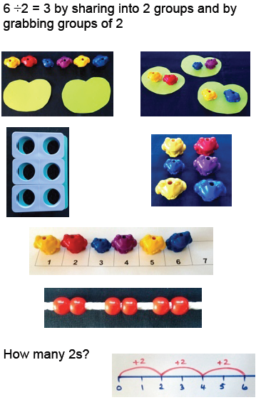
  Solve one-step problems involving multiplication and division, by calculating the answer using concrete objects, pictorial representations and arrays with the support of the teacher.

Year 2 Division
Objective | Method | Model/ Example
Recall and use multiplication and division facts for the 2, 5 and 10 multiplication tables, including recognising odd and even numbers  Calculate mathematical statements for multiplication and division within the multiplication tables and write them using the multiplication (×), division (÷) and equals (=) signs  Show that multiplication of two numbers can be done in any order (commutative) and division of one number by another cannot  Solve problems involving multiplication and division, using materials, arrays, repeated addition, mental methods, and multiplication and division facts, including problems in contexts. | The direct link between x and ÷ should always be made with the two skills being taught in conjunction with one another. Investigate how x is commutative but ÷ is not.  Introduction to the ÷ symbol  Once children are confident in their understanding of sharing and grouping they may begin to use the ÷ symbol in formal written calculations.  Children should continue to use grouping and sharing for division using practical activities, arrays and pictorial representations.  Arrays  Support children to see how an array can give both x and ÷ facts and explore these related facts.  Grouping using a number line  Group from 0 in equal jumps of 2 or 5 or 10 using the divisor as a guide to the size of each group. Make links to visual representations (then begin to investigate groups of 3 and 4). | 6 ÷ 2 = __ __ = 6 ÷ 2  6 ÷ __ = 2 3 = 6 ÷ __  __ ÷ 2 = 3 3 = __ ÷ 2  __ ÷ __ = 3 3 = __ ÷ __  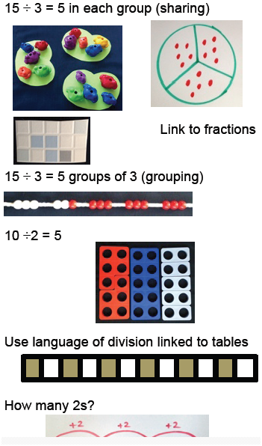

Year 3 Division
Objective | Method | Model/ Example
. | x÷ and = symbols and missing number problems  Continue to present children with a range of equations so that they are developing their fluency and reasoning skills.  Grouping  Use small numbers initially. How many 4s are in 16? How can children work this out practically/visually? Show different ways to record their findings.  Arrays leading to short division  Look at an array and ask what it shows. Investigate the different horizontal calculations it can represent (both x and ÷).  Begin to investigate bigger numbers in the same way. Introduce the layout of short division alongside an array and show pupils the correct layout focussing on place value when recording answers.  Remainders  Use sharing to find the answer to increasingly large numbers. 49 ÷ 4 = 12 but 1 is left over. How do we record this? Use counters and arrays to support children to apply their knowledge of grouping. | 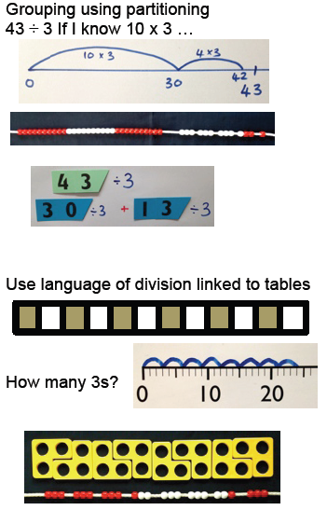  24÷6 = 4 (but not 6 ÷ 24 = 4)  Where does the dividend have to go in the calculation? (at the start because division is not commutative.)  32  3)96  Remind pupils of place value  1 8 r 2  - 4)7 5
  Recall and use multiplication and division facts for the 3, 4 and 8 multiplication tables
  Write and calculate mathematical statements for multiplication and division using the multiplication tables that they know, including for two-digit numbers times one-digit numbers, using mental and progressing to formal written methods
  Solve problems, including missing number problems, involving multiplication and division, including positive integer scaling problems and correspondence problems in which n objects are connected to m objects.

Year 4 Division
Objective | Method | Model/ Example
Recall multiplication and division facts for multiplication tables up to 12 × 12  Use place value, known and derived facts to multiply and divide mentally, including: multiplying by 0 and 1; dividing by 1; multiplying together three numbers  Recognise and use factor pairs and commutativity in mental calculations  Multiply two-digit and three-digit numbers by a one-digit number using formal written layout  Solve problems involving multiplying and adding, including using the distributive law to multiply two digit numbers by one digit, integer scaling problems and harder correspondence problems such as n objects are connected to m objects. | Missing number problems  Continue to use a range of equations as in lower years but with appropriate numbers that challenge their knowledge of all tables facts. Introduce the concept of balanced equations to ensure the concept of equivalence is embedded.  Chunking for division of larger numbers  Continue to explore division as grouping and sharing. They will now be encouraged to scale up numbers to help them to solve more complex division calculations. They may record chunks for division in informal jottings and use these to support them in their calculations. They will need to be able to recognise what happens when a number is x/÷ by 10/100  Formal written method of division  Children should be shown how to record these ‘chunks’ in more formal column divisions so they become increasingly familiar with column layout. When ready, they should be shown how to complete formal division calculations progressing to HTU ÷ U.  Calculations should continue to include both those without remainders and those with. Explore rounding up/down after division through practical tasks. | __= 60 ÷ 5 36 ÷ 9 = __ __= 360 ÷ 90  12 = __ ÷ 5 __÷ 4 = 9 4 = __÷ 90  54 ÷ 9 = 3 x __  36 ÷ 9 = 63 ÷ __  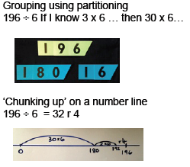  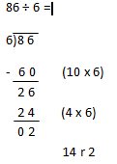  What you have x by goes on the left and is underlined, so the child knows what to add together at the end of the working out.

Year 5 Division
Objective |  | Method | Model/ Example
Identify multiples and factors, including finding all factor pairs of a number, and common factors of two numbers  Know and use the vocabulary of prime numbers, prime factors and composite (non-prime) numbers  Establish whether a number up to 100 is prime and recall prime numbers up to 19  Multiply numbers up to 4 digits by a one- or two-digit number using a formal written method, including long multiplication for two-digit numbers  Multiply and divide numbers mentally drawing upon known facts  Divide numbers up to 4 digits by a one-digit number using the formal written method of short division and interpret remainders appropriately for the context  Multiply and divide whole numbers and those involving decimals by 10, 100 and 1000 |  | ÷ x and = signs and missing numbers  Continue to provide a range of equations with appropriate numbers.  Formal written method for division  Continue as for Year 4 until pupils are efficient in their use of either chunking or more standard method. Pupils should be confident when x/÷ by 10/100/1000  Remainders (quotient) expressed in different ways  Provide calculations that have remainders and ask pupils to discuss the way in which the remainder is recorded. What does it mean? Show that it can also be written as a fraction or a decimal. Work through examples of each.  Through practical problems solving tasks look at how the remainder may lead to rounding up/down depending on the context of the question. Explore how the quotient could also be divided to give a decimal (and more accurate) answer.  Division using chunking  As children become more confident with HTU ÷ u they will be introduced to HTU ÷ TU for which they may again use chunking. | 630 ÷ __=9 __ ÷ 9 =0.7 __ ÷ __ = 63  __ ÷ 90 = 70 100 ÷ __=__÷ 2  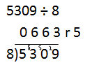  The remainder could be expressed as five eighths , r5, as a decimal number, or rounded up or down as appropriate for the problem.  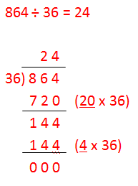  What you have x by goes on the left and is underlined, so the child knows what to add together at the end of the working out.

Year 6 Division
Objective | Method | Model/ Example
Multiply multi-digit numbers up to 4 digits by a two-digit whole number using the formal written method of long multiplication  Divide numbers up to 4 digits by a two-digit whole number using the formal written method of long division, and interpret remainders as whole number remainders, fractions, or by rounding, as appropriate for the context  Divide numbers up to 4 digits by a two-digit number using the formal written method of short division where appropriate, interpreting remainders according to the context  Perform mental calculations, including with mixed operations and large numbers  Use estimation to check answers to calculations and determine, in the context of a problem, an appropriate degree of accuracy. | ÷ x and = signs and missing numbers  Use a range of appropriate equations and begin to include those with decimal numbers. Multiplication should be used as a check for division accuracy.  Short division with remainders  Children should develop their confidence when expressing remainders as whole numbers, fractions, decimals or rounded numbers depending on the contexts.  Chunking leading to long division.  As children become increasingly confident with HTU ÷ TU they may move to Th HTU ÷ TU. They may then explore the link between chunking and long division and discuss the efficiency of each method.  At all times a range of calculations should be provided with remainders as well as those without. Remainders should be interpreted according to the context. | 630 ÷ 0.7 = 2.75 ÷5 = __ __ ÷ 0.4 = __ ÷ 0.25  