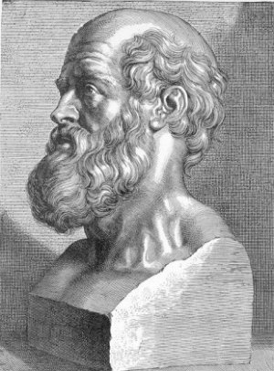
Hippocrates

Father of Medicine
Born in 460 B.C. - Died in 377 B.C.

Hippocrates (hih POK ruh teez) lived 400 years before the birth of Christ. He is known as the father of medicine because many of the things he discovered are still practiced today.
During the time when Hippocrates lived, people were very superstitious. They believed there were four fluids in the body which matched four elements; earth, air, fire and water. They would carry sick people to the temple because they thought the god of medicine, Aesculapius (es kyoo LAY pe us) could heal them. They would say magic words over the patient to try and heal them.
Hippocrates taught that diseases came from natural causes. He had observed many patients and carefully recorded their symptoms and the way their illnesses developed. He would look at the colour of the skin, and how the eyes looked. He would look for fevers and chills. He described many illnesses including:
- tetanus,
- malaria.
- tuberculosis,
- arthritis,
- mumps,
- pneumonia,
He told his students to carefully observe their patients and to learn from the things they had observed. He said the human body could heal itself and could return itself to good health. The patient was given something to relieve pain, but nothing else was done.
He told his patients they should eat a moderate amount of food; not too much and not too little. A moderate amount of exercise was recommended. Patients were encouraged to walk for exercise.
Doctors were told to make sure their hands were clean before they treated patients. He said the operating room should be well lighted and look cheerful. He thought patients in good spirits would heal faster.
Doctors were told to make sure their hands were clean before they treated patients. He said the operating room should be well lighted and look cheerful. He thought patients in good spirits would heal faster.
Physicians should be men of honour, according to Hippocrates. He encouraged them to work as hard as possible for the good of the sick.
The Hippocratic (hip uh CRAT ick) Oath was named for him. It included rules of conducts for doctors and even today doctors still honour a form of the oath.
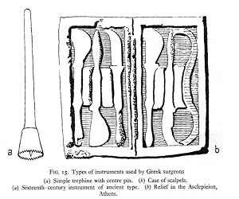

Ancient Greek Surgical Instruments

