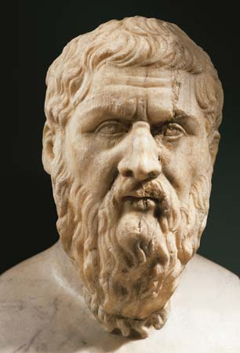
Plato
The Athenian philosopher Plato (c.428-347 B.C.) is one of the most important figures of the Ancient Greek world and the entire history of Western thought. In his written dialogues he conveyed and expanded on the ideas and techniques of his teacher Socrates. The Academy he founded was by some accounts the world’s first university and in it he trained his greatest student, the equally influential philosopher Aristotle. Plato’s recurring fascination was the distinction between ideal forms and everyday experience, and how it played out both for individuals and for societies. In the “Republic,” his most famous work, he envisioned a civilization governed not by lowly appetites but by the pure wisdom of a philosopher-king.

PLATO: EARLY LIFE AND EDUCATION
Plato was born around 428 B.C., during the final years of the Golden Age of Pericles’ Athens. He was of noble Athenian lineage on both sides. His father Ariston died when he was a child. His mother Perictione remarried the politician Pyrilampes. Plato grew up during the Peloponnesian War (431-404) and came of age around the time of Athens’ final defeat by Sparta and the political chaos that followed. He was educated in philosophy, poetry and gymnastics by distinguished Athenian teachers including the philosopher Cratylus.
The young Plato became a devoted follower of Socrates
When he was older, Plato spent 12 years traveling in southern Italy, Sicily and Egypt, studying with other philosophers including followers of the mystic mathematician Pythagoras. He began a lifelong relationship with the ruling family of Syracuse, who would later seek his advice on reforming their city’s politics.
Around 387, the 40-year-old Plato returned to Athens and founded his philosophical school in the grove of the Greek hero Academus, just outside the city walls. In his open-air Academy he delivered lectures to students gathered from throughout the Greek world. Many of Plato’s writings, especially the so-called later dialogues, seem to have originated in his teaching there. In establishing the Academy Plato moved beyond the precepts of Socrates, who never founded a school and questioned the very idea of a teacher’s ability to impart knowledge.
Aristotle arrived from northern Greece to join the Academy at age 17, studying and teaching there for the last 20 years of Plato’s life. Plato died in Athens, and was probably buried on the Academy grounds.
All of Plato’s surviving writings are in dialogue form, with the character of Socrates appearing in all but one of them. His 36 dialogues are generally ordered into early, middle and late, though their chronology is determined by style and content rather than specific dates.

PLATO: LEGACY AND INFLUENCE
The Academy flourished for nearly three centuries following Plato’s death, but was destroyed in the sacking of Athens by the Roman general Sulla in 86 B.C. Though continually read in the Byzantine Empire and in the Islamic world, Plato was overshadowed by Aristotle in the Christian west. It was only in the Renaissance that scholars like Petrarch led a revival of Plato’s thought, in particular his explorations of logic and geometry. William Wordsworth, Percy Shelly, and others in the 19th-century Romantic movement found philosophical solace in Plato’s dialogues.

