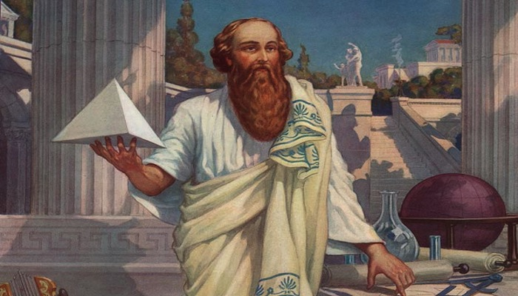
Pythagoras: Facts and Information
It is sometimes claimed that we owe pure mathematics to Pythagoras, and he is often called the first "true" mathematician. But, although his contribution was clearly important, he nevertheless remains a controversial figure. He left no mathematical writings himself, and much of what we know about Pythagorean thought comes to us from the writings of Philolaus and other later Pythagorean scholars. Indeed, it is by no means clear whether many (or indeed any) of the theorems ascribed to him were in fact solved by Pythagoras personally or by his followers.

- Pythagoras was an Ancient Greek mathematician and philosopher.
He was born on the Greek island of Samos around 570 BC and died in Greece probably around 495 BC.
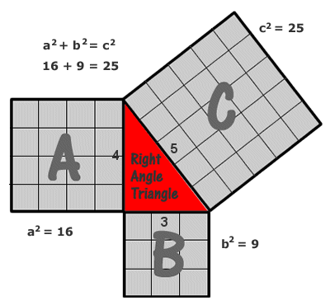
- In 530 BC he moved to Italy and established a religious group known as the Pythagoreans. The group was very secretive and were vegetarians who worshipped the God Apollo. They didn’t own any possessions.
- He is best known for the Pythagorean theory named after him. Often referred to as Pythagoras’ Rule, Pythagoras’ Theorem states that in a right-angled triangle, the square on the hypotenuse is equal to the sum of the squares on the other two sides.

- He believed that science and religion were connected. He also believed that the human soul returned over and over again into people, animals and even vegetables.
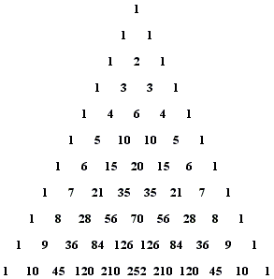
- Pythagoras believed that he had already lived four lives, all of which he could remember. Others claimed that he was able to travel through space and time and could talk to plants and animals.

- Pythagoras believed the Earth was round and that mathematics could explain the physical world. He also devised the triangular figure of 4 rows, adding up to 10 and believed the design to be sacred.

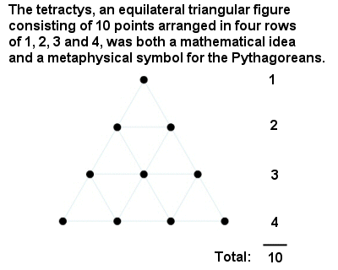

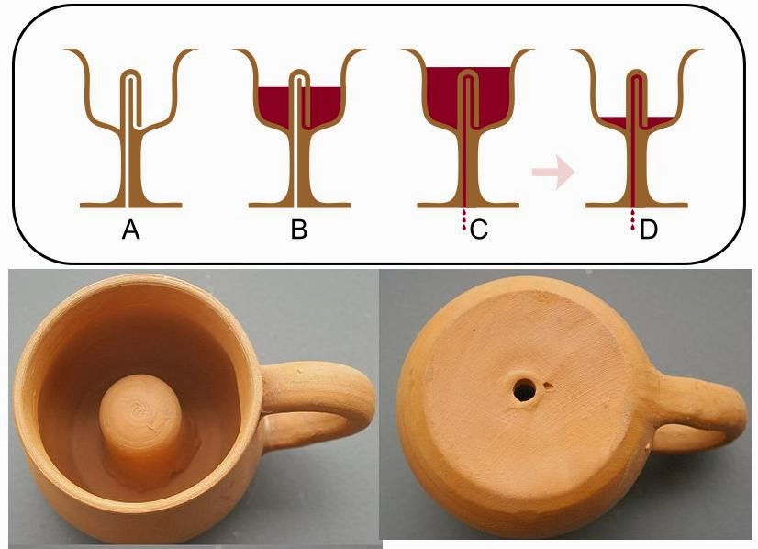
- A special type of cup is credited to Pythagoras. The cup works normally when the user sips from it, although the contents are spilled if the user drinks too quickly.

- Pythagoras may have had a condition known as synesthesia. A person with the condition is said to be able to hear colours and see music, or associate smells with people’s names.
- No books or writings by Pythagoras have survived. He probably taught by speaking to his followers, although in the centuries after his death, several forgeries were discovered.
- The philosopher Plato was influenced by Pythagoras, and thought that mathematics affected philosophy. Pythagoras also influenced the establishment of the Freemasons and other secret societies.

