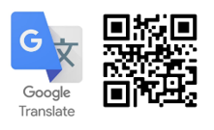
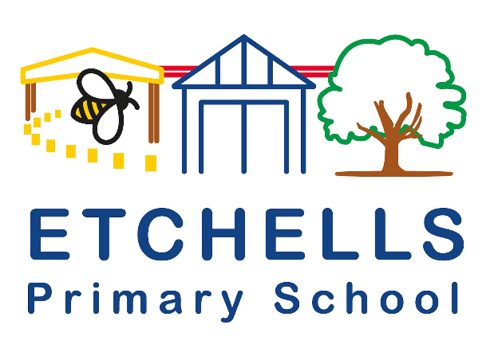

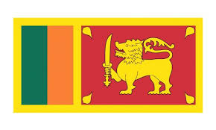
Etchells Primary School Language of the half term:

Sinhala

Sinhala, sometimes called Sinhalese, is an Indo-Aryan language primarily spoken by the Sinhalese people of Sri Lanka, who make up the largest ethnic group on the island, numbering about 16 million.
English | Transcription | Translation
Hello | ආයුබෝවන් | āyubōvan
Thank you | ඔයාට ස්තූතියි | oyāṭa stūtiyi
Good morning | සුභ උදෑසනක් | subha udǣsanak
Welcome | සාදරයෙන් පිළිගනිමු | sādarayen piḷiganimu
Please | කරුණාකර | karuṇākara
We have more almost 3 children at Etchells who can speak Sinhala or who hear Sinhala being spoken at home or in their community.

