

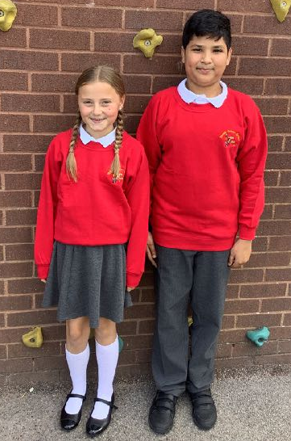

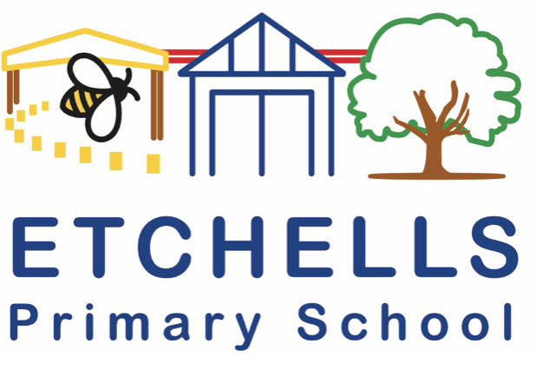
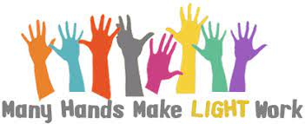

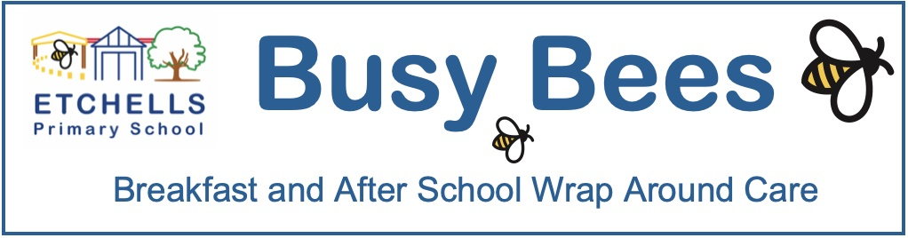
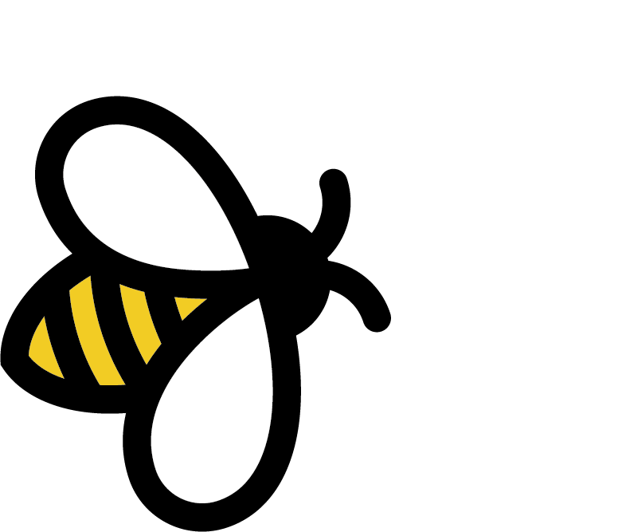

This week saw the launch of our new wrap around care - Busy Bees Club. The room has had a revamp and organisation over the Easter Holidays. Our managers, Mrs Haastrup and Miss Billinge, have done an excellent job of welcoming the children into the new provision. We have had some really positive feedback about the new wrap around care.
For those using the Tax Free Childcare Vouchers, we are still awaiting our registration number from Ofsted so that this can be claimed back; as soon as we have this then we will share this with you. Thank you for your patience in the meantime.
We are hoping to set up some theme days in the provision over the next few weeks, so keep a close eye on the Newsletter for exciting events that will be happening in our Busy Bees Club.

Eid Celebrations | Busy Bees Club | Language of the half term
school news
Eid Celebration
Today, we marked our annual Eid celebration in school. Each class had their own celebration, sharing their experiences of how different families spent their Eid. Classes have done parties including: dancing, sharing food, Mehndi patterns and party games. It was lovely to see all the children arrive at school in their party clothes and with huge smiles on their faces, ready for the festivities of the day. Thank you to all the families who provided snacks and food for the celebrations, it was very much appreciated.
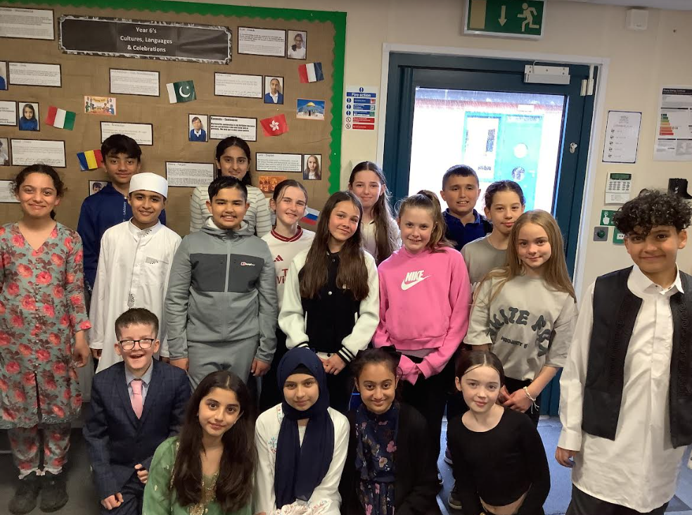

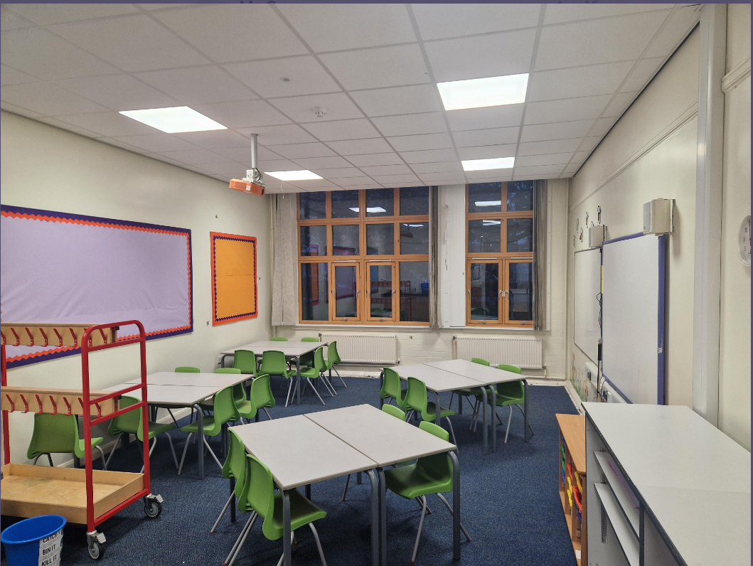

Kind regards,
Pete Cope and the Etchells staff

There are still places available in our cricket club, which takes place on a Tuesday after school, run by Mr Wistow. He will be incorporating elements of rounders in the club as well, hopefully using the field when the weather improves. We are also going to be opening up the club to all children in Year 4, if you would like a place in the club then please book a place using Eduspot.
Also, there are still places in our tennis club, which runs after school on a Friday. This is being run by Point One Tennis. If you are looking to book onto this club please follow the link provided: https://www.point-onetennis.org/schoolsparentsarea.

After School Clubs - Cricket and Tennis

World Earth Day
Next Monday (22nd April) marks annual World Earth Day. World Earth day is one of the most prominent annual awareness days that sheds light on the importance of our planet’s health and the role that we play as a school to preserve it. This year’s theme is Planet vs Plastics. The children will be completing work next week around this topic and as a school we will be looking at how we can become more sustainable.
Language of the Half Term
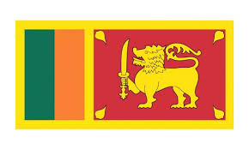
Sinhala
The language of the half term will be Sinhala. Sinhala, sometimes called Sinhalese, is an Indo-Aryan language primarily spoken by the Sinhalese people of Sri Lanka, who make up the largest ethnic group on the island, numbering about 16 million people.
In school, we have 3 children who can speak Sinhala or who hear Sinhala being spoken at home or in their community. Please find the attachment for more information on the Language of the Half Term.
Please also find attached the Etchells Primary School Summer term learning challenge. The Summer Term language challenge is all about speaking, reading and writing in a home language and learning about how it feels to learn another language. Please select one or more of the activities from the attachment to complete. All of the tasks in the challenge are linked to our computing curriculum.

