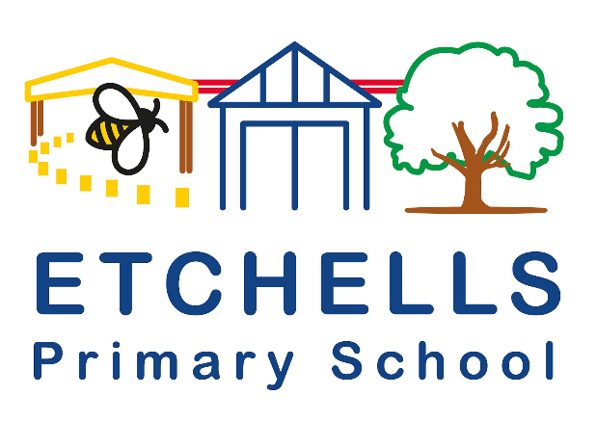

Etchells Primary School Language of the half term:

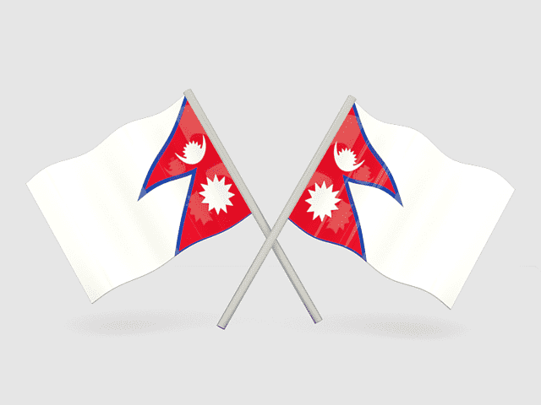**Nepali**

Nepali is spoken by more than 17 million people, mostly in Nepal and neighbouring parts of India. Smaller speech communities exist in Bhutan, Brunei, and Myanmar.

|  |  |
| --- | --- |
| **English** | **Translation** |
| Hello | नमस्कार  Namaskāra |
| Thank you | धन्यवाद  Dhan'yavāda |
| How are you? | कस्तो छ ?  Kastō cha? |
| Excuse me | मलाई माफ गर्नुहोस्  Malā'ī māpha garnuhōs |
| Nice to meet you | तिमीलाई भेटेर खुशी लाग्यो  Timīlā'ī bhēṭēra khuśī lāgyō |

At Etchells we have 2 children who speak or hear Nepali being spoken at home.