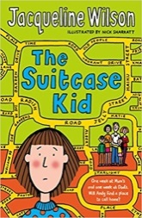
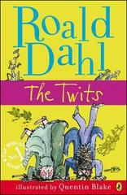
Year 4 Reading Challenge
How many of these books can you read this year?
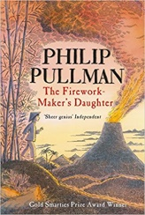
Recommended Reading List:
- Max and the Millions by Ross Montgomery
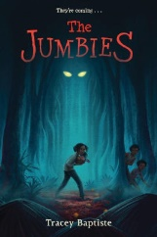
- Desirable by Frank Cottrell Boyce
- My Brother is a Superhero by David Solomons
- There’s a Werewolf in My Tent by Pamela Butchart
- The 13 Storey Treehouse by Andy Griffiths
- Frank Einstein and the Antimatter Motor by Jon Scieszka
- The Peppermint Pig by Nina Bawden
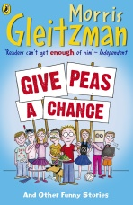
- Operation Gadgetman! by Malorie Blackman
- The Children of Green Knowe by Lucy M.Boston
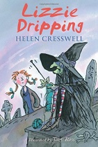
- How to Train Your Dragon by Cressida Cowell
- Lizzie Dripping by Helen Cresswell
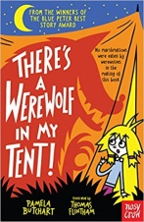
- The Great Elephant Chase by Gillian Cross
- The Twits by Roald Dahl
- Charlie and the Chocolate Factory by Roald Dahl
- Little Leaders by Vashti Harrison
- The Jumbies by Tracey Baptiste
- Rise of the Jumbies by Tracey Baptiste
- Emanuel’s Dream: A true story of Ofosu Yeboah by Laurie Ann Thompson & Sean Qualls
- Listen Slowly by Thanhha Lai
- All Mixed Up (Amy Hodgepodge) by Kim Wayans and Kevin Knotts
- War Game by Michael Foreman
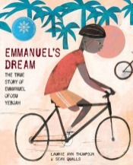
- Harry Potter & The Philosopher’s Stone by J.K Rowling
- Harry Potter & The Chamber of Secrets by J.K Rowling
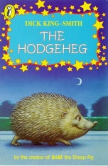
- Toad Rage by Morris Gleitzman
- The Last Castaways by Harry Horse
- The Falcon’s Malteser by Anthony Horowitz
- The Akimbo Adventures by Alexander McCall Smith
- Fairy Tales by Terry Jones
- The Hodgeheg by Dick King-Smith
- The Worst Witch by Jill Murphy
- The Way to Sattin Shore by Philippa Pearce
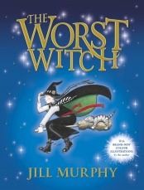
- The Firemaker’s Daughter by Philip Pullman
- Cloud Tea Monkeys by Juan Wijngaard & Mal Peet
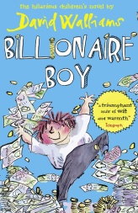
- The Suitcase Kid by Jacqueline Wilson
- George’s Marvellous Medicine by Roald Dahl
- Billionaire Boy by David Walliams
- Awful Auntie by David Walliams
- Cliffhanger by Jacqueline Wilson
- The Legend of Captain Crow’s Teeth by Eoin Colfer
- The Invisible Dog by Dick King-Smith
- Charlotte’s Web by E.B White
- The Battle of Bubble and Squeak by Philippa Pearce
- Give Peas a Chance by Morris Gleitzman
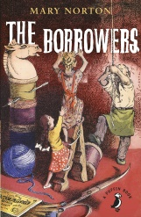
- Malala Yousafzai; Warrior with Words by Karen Leggett Abouraya
- The Amazing Story of Adolphus Tips by Michael Morpurgo
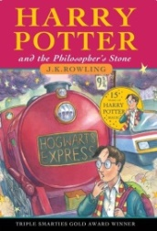
- The Yearling by Marjorie Rawlings
- Diary of a Wimpy Kid by Jeff Kinney
- The Demon Headmaster by Gillian Cross
- The Borrowers by Mary Norton
- The Lion, The Witch & The Wardrobe by C.S Lewis

